**NEXT GENERATION LOGISTICS -**

**APPOINTMENT MANAGEMENT SYSTEM**

USER DOCUMENTATION

# Overview

The user document is intended to help and assistance to the users in using the scheduler and its related features of this module. This document provides screenshots of the relevant functionality and explains in detail about the available functionalities.

# Warehouse Scheduler

The Warehouse scheduler page provides the ability for authorized users to view the schedule for the selected ware house. The scheduler page shows the Calendar with different views (daily, weekly, monthly and timeline) to see already scheduled appointments for the orders.

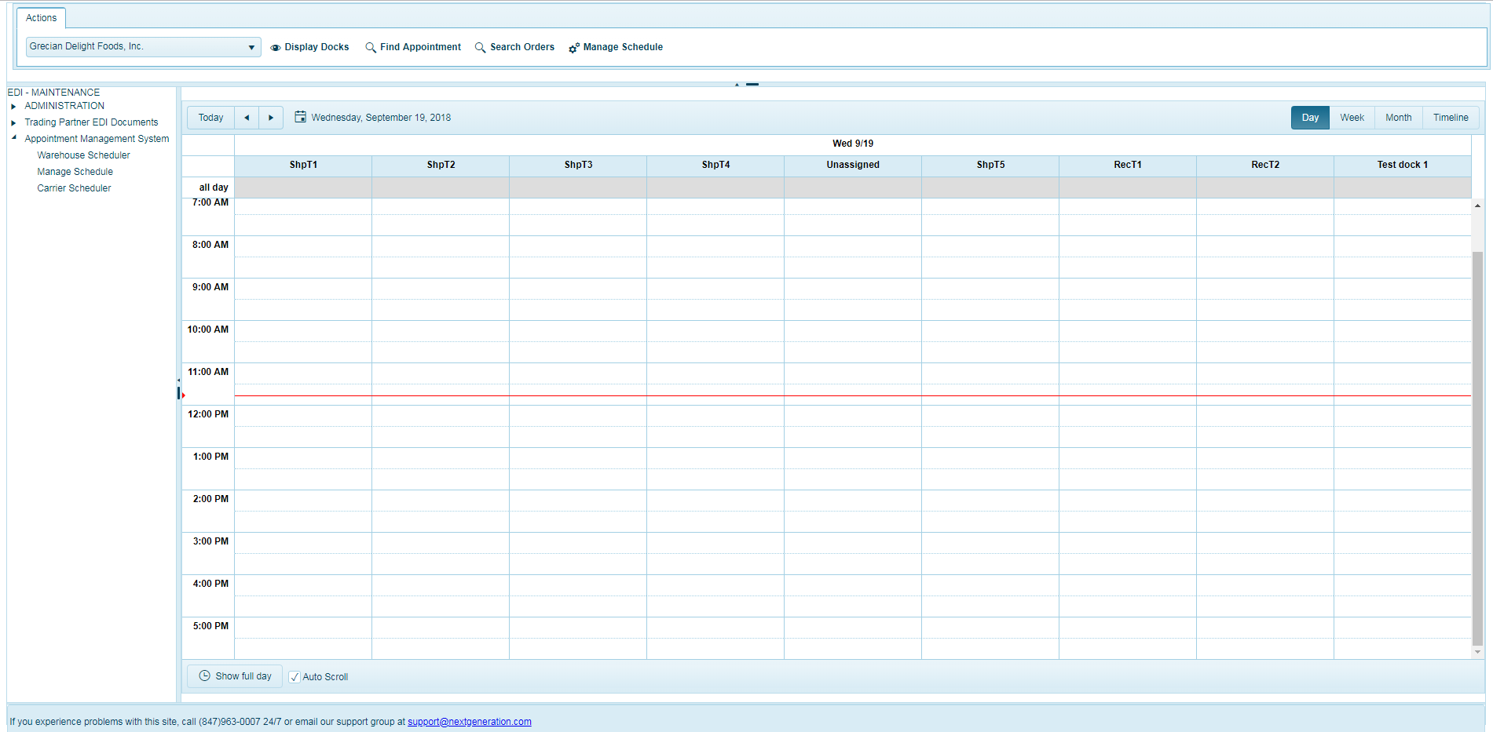

* 1. **Select Warehouse**

The authorized user should select the warehouse from the drop down available in the Actions menu of the page. The drop down lists the ware houses the user has access for scheduling the appointments for Pickup and Delivery Orders.

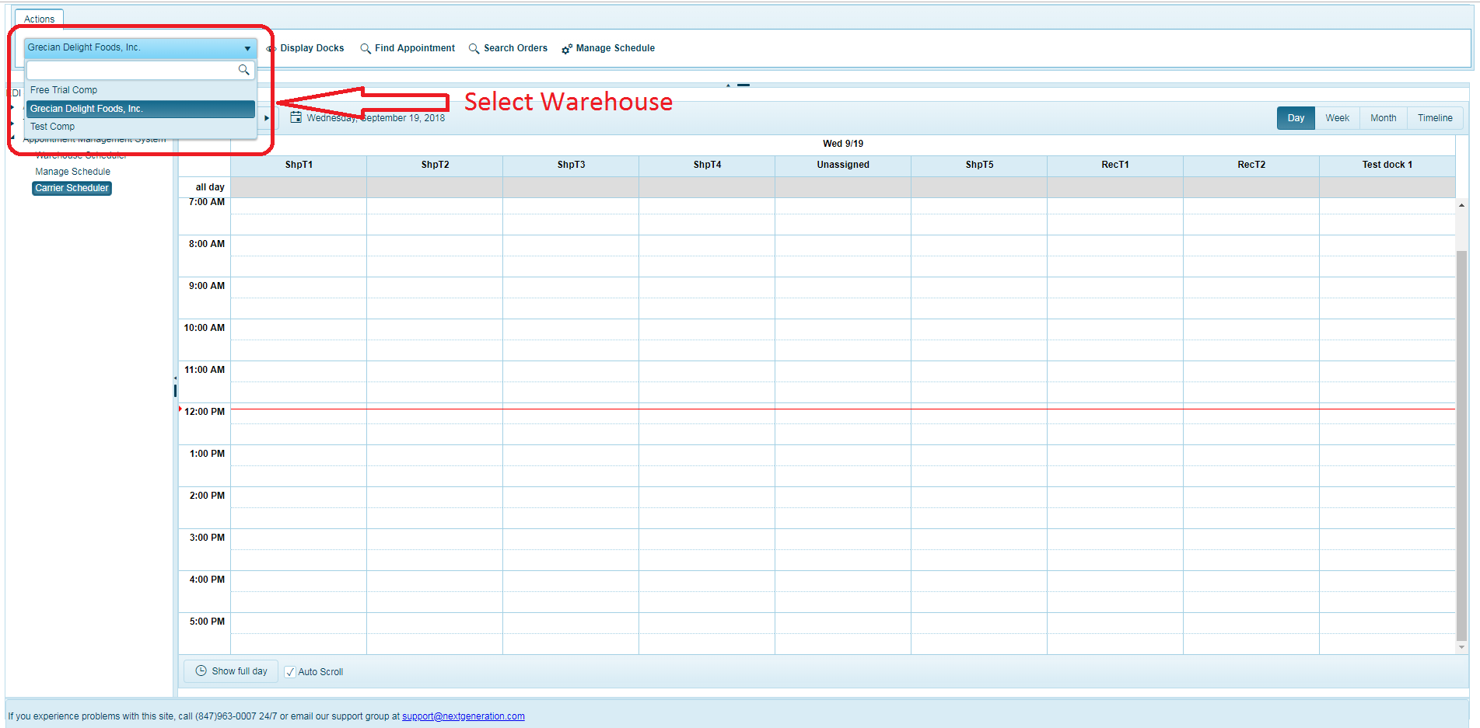

Once the user selects a ware house from the drop down the calendar refreshes and displays the already scheduled appointments.

* 1. **Find My Appointment**

The Find My Appointment feature allows the user to search for the appointments based on the selected search criteria with the appointments satisfying the criteria listed in the grid.

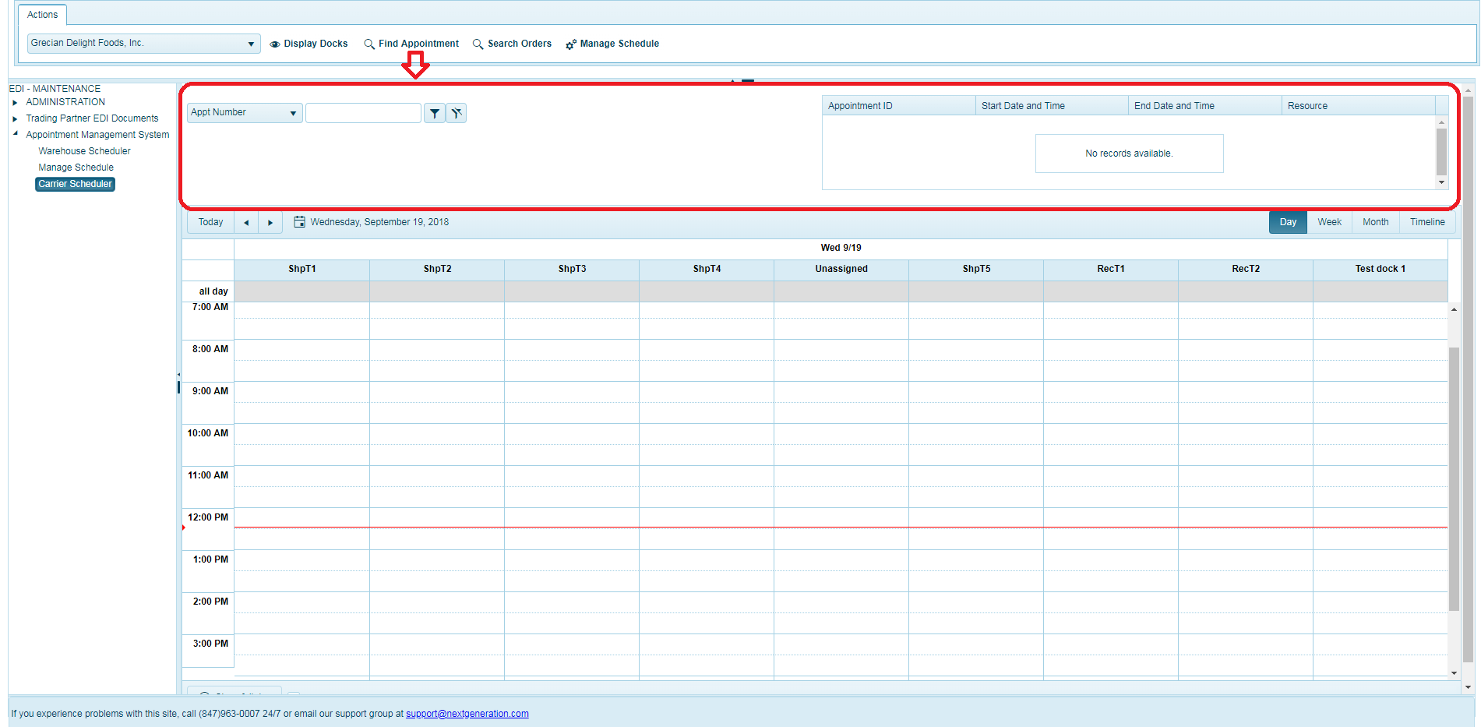

1. Select one of the search criteria from the dropdown in Find Appointment section as seen in the screenshot below:

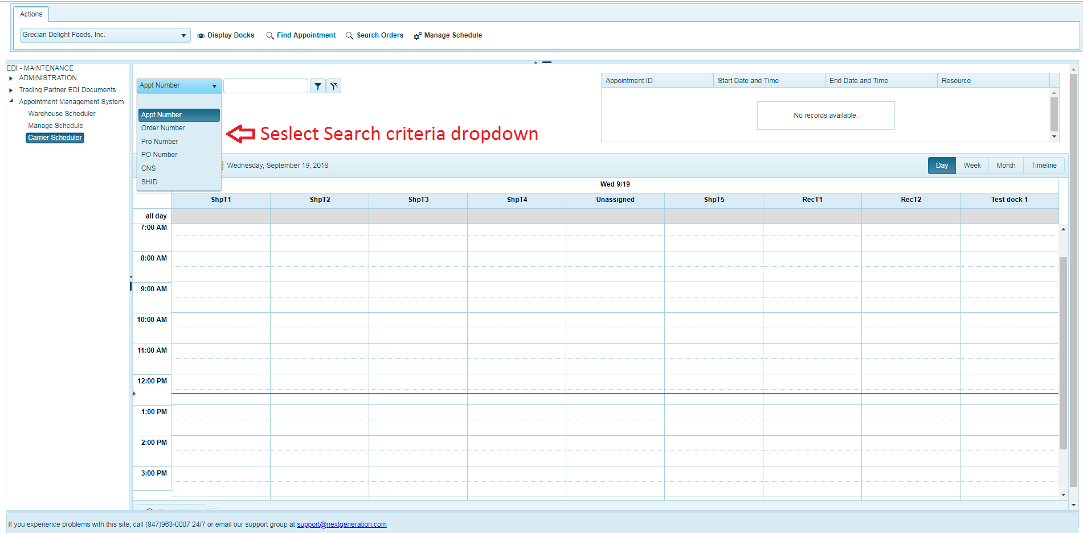

1. Input appropriate search value in the input box and search by clicking filter button.

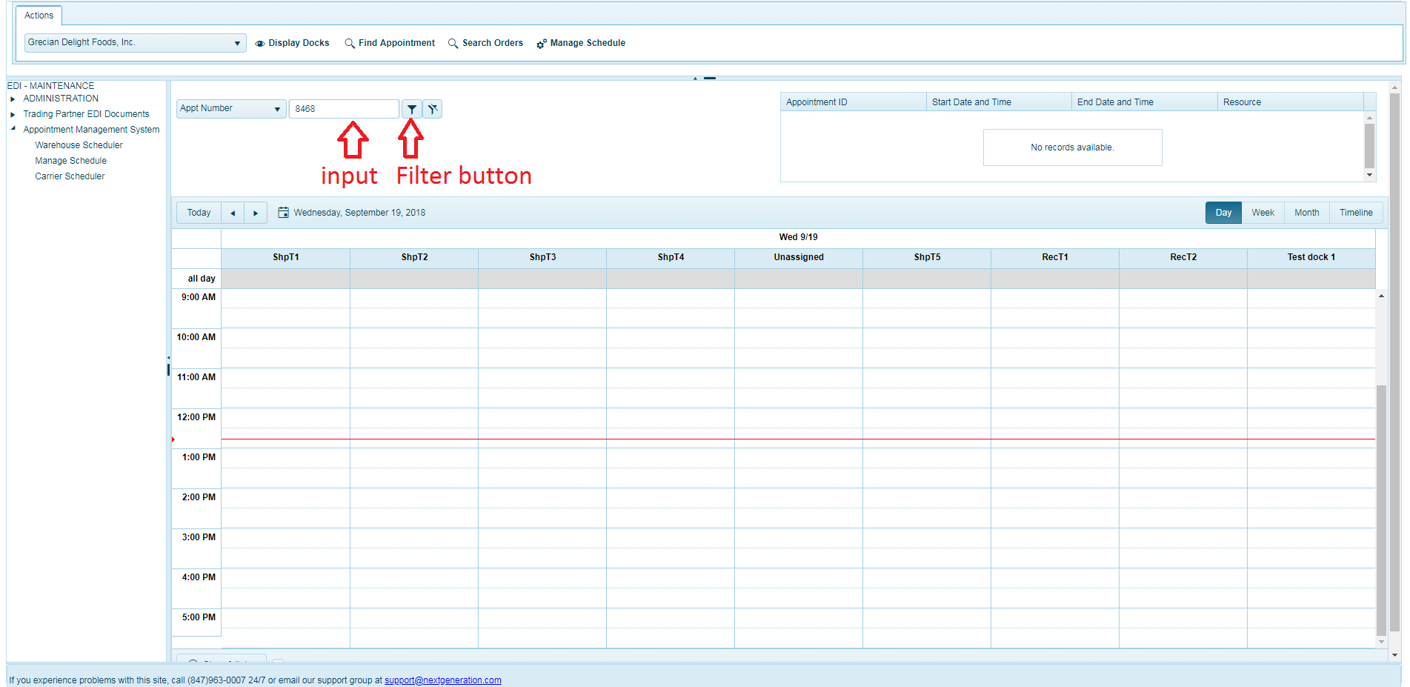

1. The search results matching the search criteria are displayed in the grid and can also be seen in the calendar, as seen in the screenshot below.

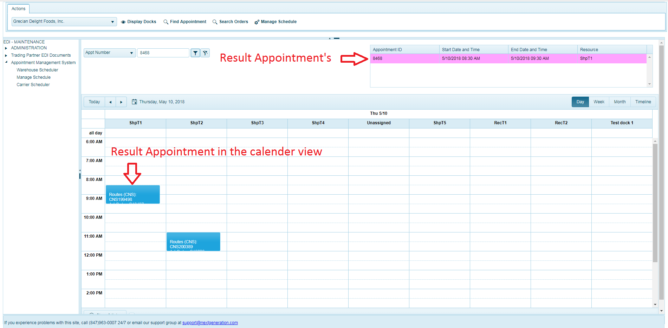

* 1. **Display Docks**

The display Docks feature displays the available list of dock doors for the user to tick/un-tick the dock doors if they wish to see necessary dock doors. Once the dock doors are ticked/un-ticked the calendar refreshes displaying the appropriate docks and scheduled appointments.

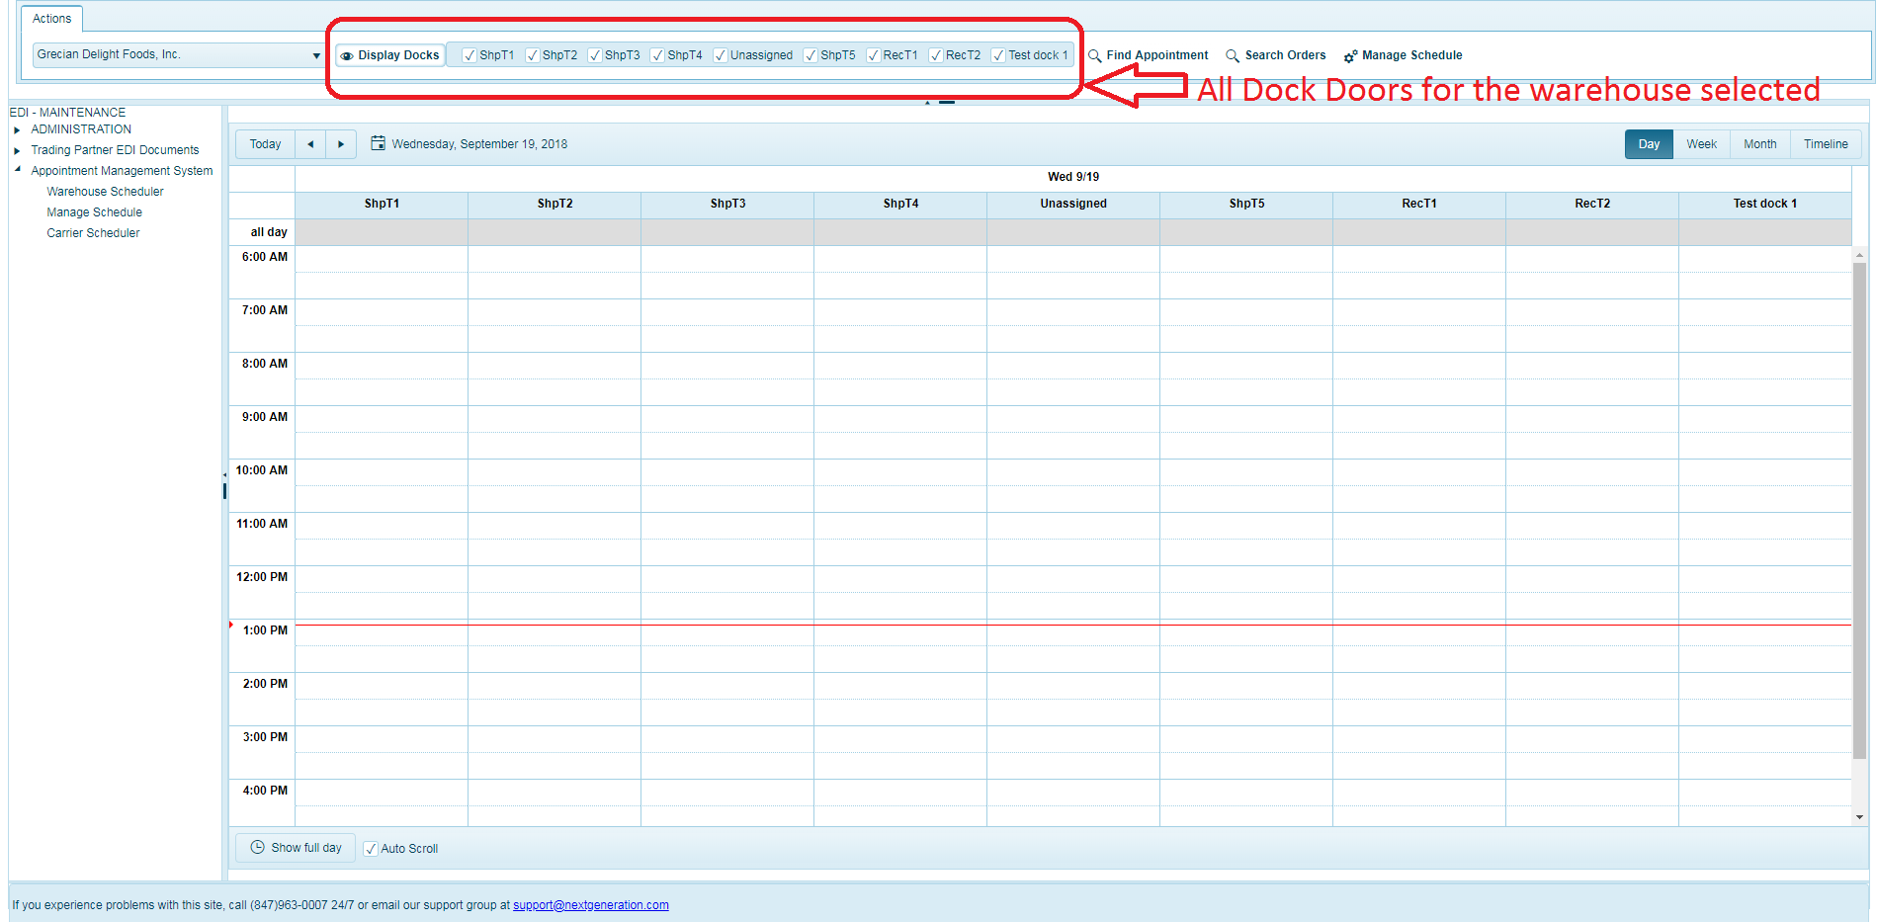

As in the above Dock Doors list we can able to display Dock Doors in the calendar view based on the selection by checking the checkbox.

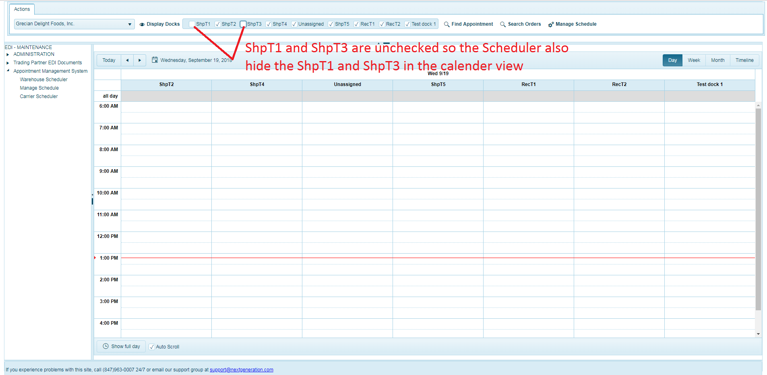

* 1. **Search Orders**

Search Orders is the feature will allow the user to search the Orders based on the search filter. The grid initially lists the available list of Orders for the applicable date range and selected warehouse (if any orders available) in the calendar view.

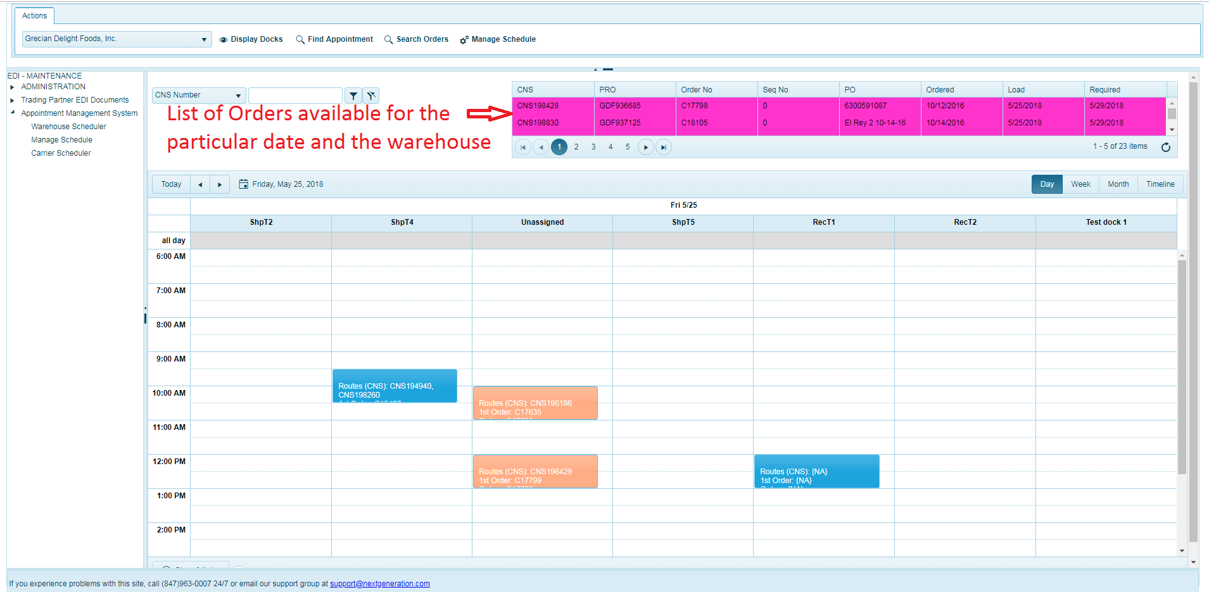

1. Select the Search criteria based on the dropdown in the Search Orders section as seen in the screenshot below.

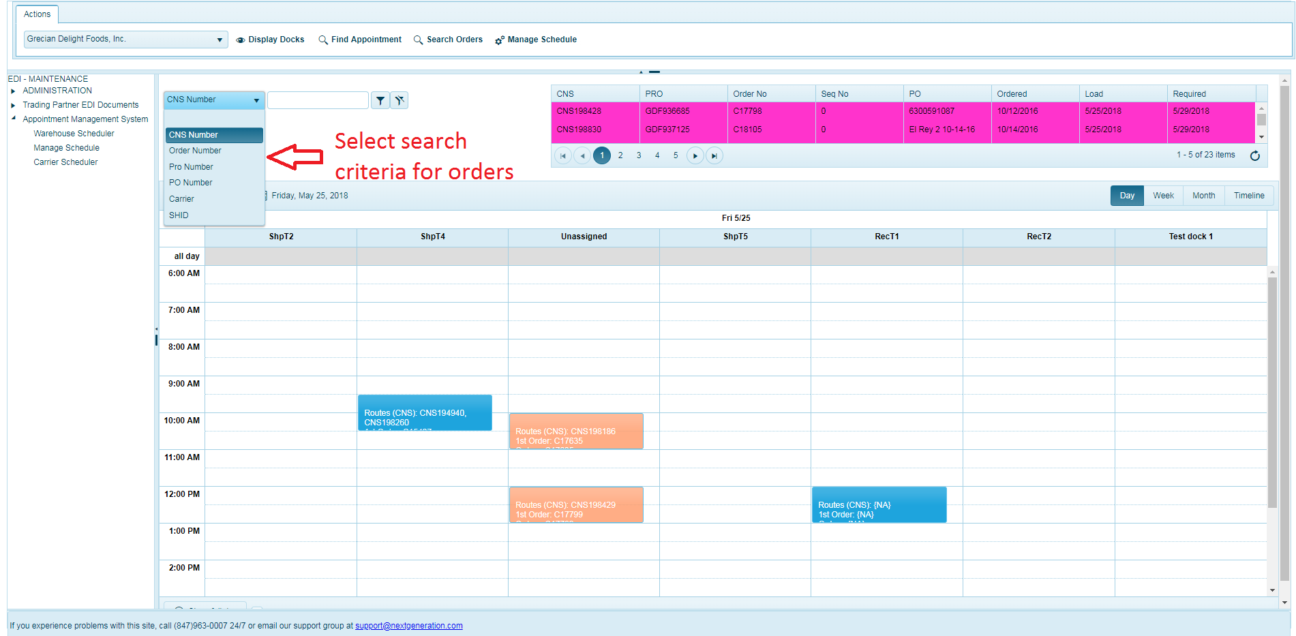

1. Enter the Input value and click the filter button as seen in screenshot below.

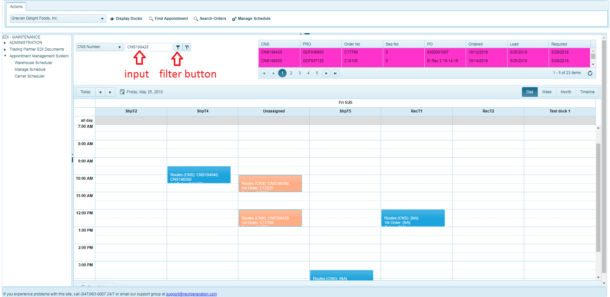

1. The orders matching the search criteria are displayed in the grid.

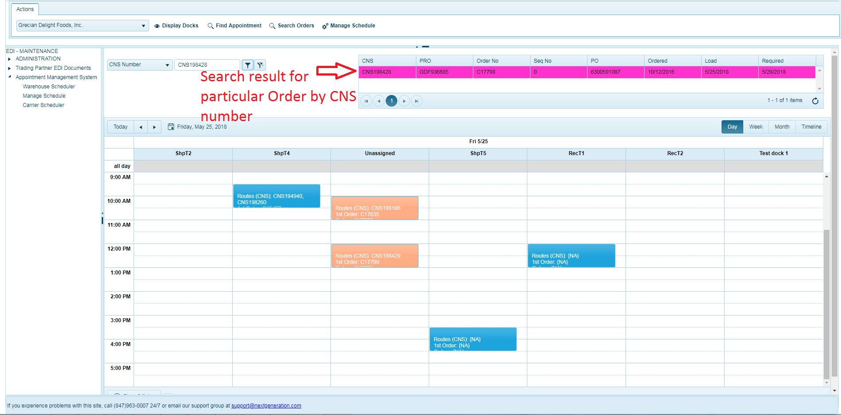

* 1. **Scheduling Calendar – Day, Week, Month and Timeline Views**

1. The scheduling calendar displays the day view by default for the current date with all dock doors for the selected warehouse.
2. User can navigate to different dates in the calendar view and also switch to different view such as Day, Week, Month and Timeline.
3. The calendar provides toggle button for the calendar to show the time slots for the Work hours in particular day or for the entire day.
4. User can switch or toggle between these views by clicking on the button available at the bottom of the calendar
5. The scheduling calendar also provides “Auto Scroll” feature which automatically scrolls the calendar view to the current time so that it is on when the Auto Scroll is set to ON.

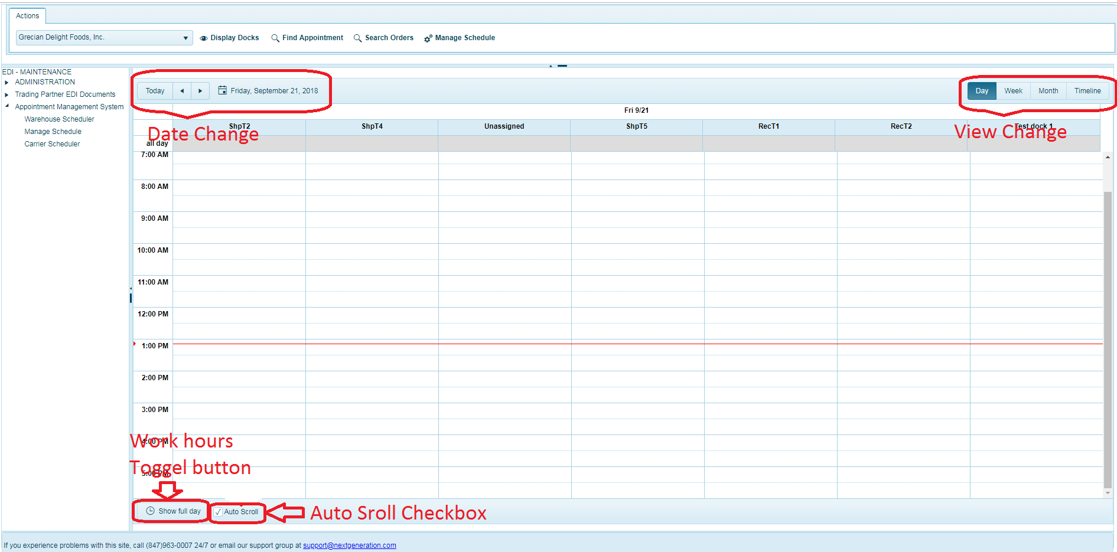

* 1. **Add/Edit Appointment**

This section allows the user to schedule a new appointment in the calendar for an existing order or for an ad hoc order. The user can edit already scheduled appointment to edit appointment or the order details.

1.6.1 **Add Appointment to an Order**

This feature allows scheduling an appointment for a new order or existing order in different ways detailed below:

1. Schedule a new appointment by double click on the calendar view.
2. Right click on the calendar view to get the context menu and Select ‘Add Appointment’ option.

And

1. Drag and Drop an order from the orders grid to the appropriate time slot and dock door in the calendar view.

Once the user has successfully chosen the order and selected an appointment time slot, the ‘Add Appointment’ popup window opens as seen in the screenshot below.

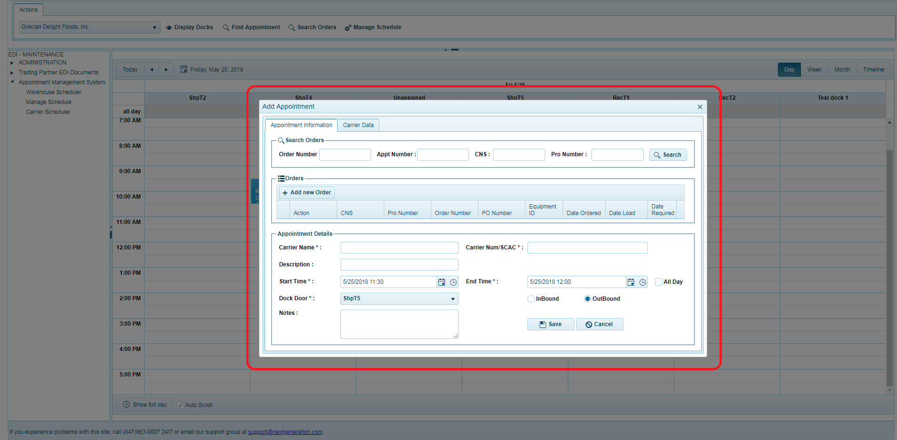

If the user drags an order from orders grid to the calendar view, the order along with the default data will be filled in by orders as seen in the screenshot below.

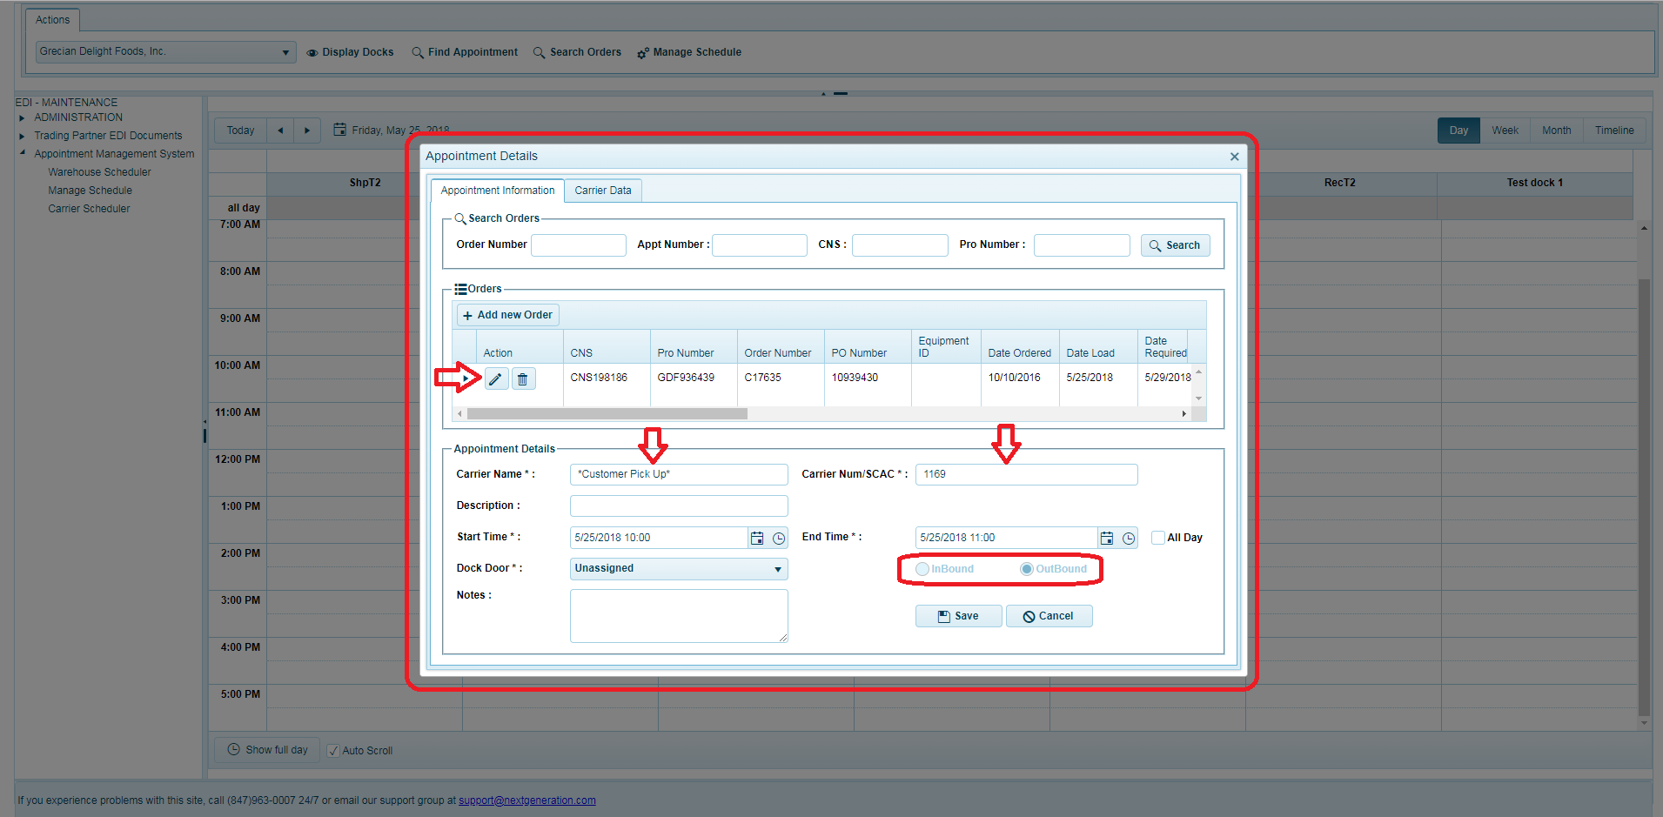

Once ‘Add Appointment’ popup window opens, the user can fill in details of the appointment & the dock door.

Once the details are filled in the user should click “save” to save the appointment details and schedule an appointment, they can click “cancel” button if they don’t want to continue scheduling an appointment.

1.6.2 **Edit Appointment**

An appointment already scheduled in the system can also be edited to amend the appointment or order details. The appointment details can be edited choosing one of the ways detailed below:

1. Double click on an already scheduled appointment in the calendar
2. Right click on an existing appointment to get context menu and select ‘Update Appointment’ option
3. Right click on an existing appointment to get context menu and select ‘Carrier Data’ option to update the update the Check-in, checkout & other details

And

1. Drag and Drop an existing appointment in the scheduling calendar to another time slot in same dock door or different dock door in the calendar

The appointment details popup makes appointment information available in two tabs namely ‘Appointment Information’ and ‘Carrier Data’.

**Appointment Information Tab**

The Appointment information tab consists of 3 sub sections namely search orders, orders and appointment details.



1. User can search for orders by inputting the keyword in one of the search criteria and click on “Search” button to search orders. The search result displays the orders matching the criteria and it will add into orders grid of the Orders section.
2. Orders section displays orders that are orders which are dragged & dropped from orders grid and searched orders.
3. The user can add, edit and delete the Orders from the orders section by clicking on “+Add new Order” button available in orders grid toolbar.
4. Once the user clicks on “+Add new Order” button, the section with input fields are displayed to add the new Ad hoc order by entering the order details as seen in screenshot below.

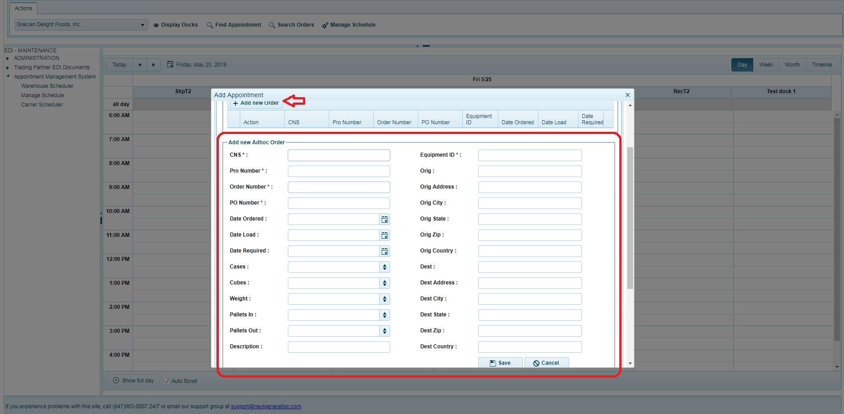

1. After entering the ad hoc order details the user can save the order by clicking on “Save” button or cancel adding the ad hoc order by clicking “Cancel” button.
2. Once the user saves ad hoc order the order will added and listed in the Orders grid.
3. The user can also edit the order details by clicking on “Edit” button in the first column of the grid for a particular order in the orders list.
4. When clicking on the “Edit” button for an order the order details section opens with the Orders details as seen in the screenshot below:

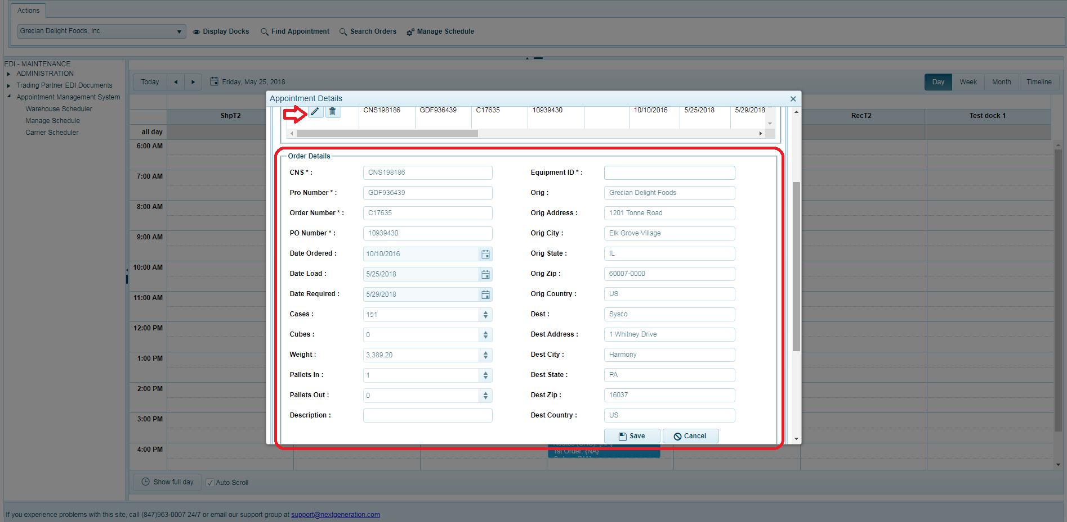

1. Once the order details are modified the user need can save the details by clicking on “Save” button for save changes or click on “Cancel” button to cancel saving the changes made.
2. If the user wants to delete the orders from the appointment, the user can delete by clicking on Delete  button on the particular order row that needs to be deleted from action column in the list.
3. A confirmation dialog box is displayed for the user to confirm removing the order record from the appointment, click “OK” to delete particular Order or “Cancel” to cancel deleting the order.

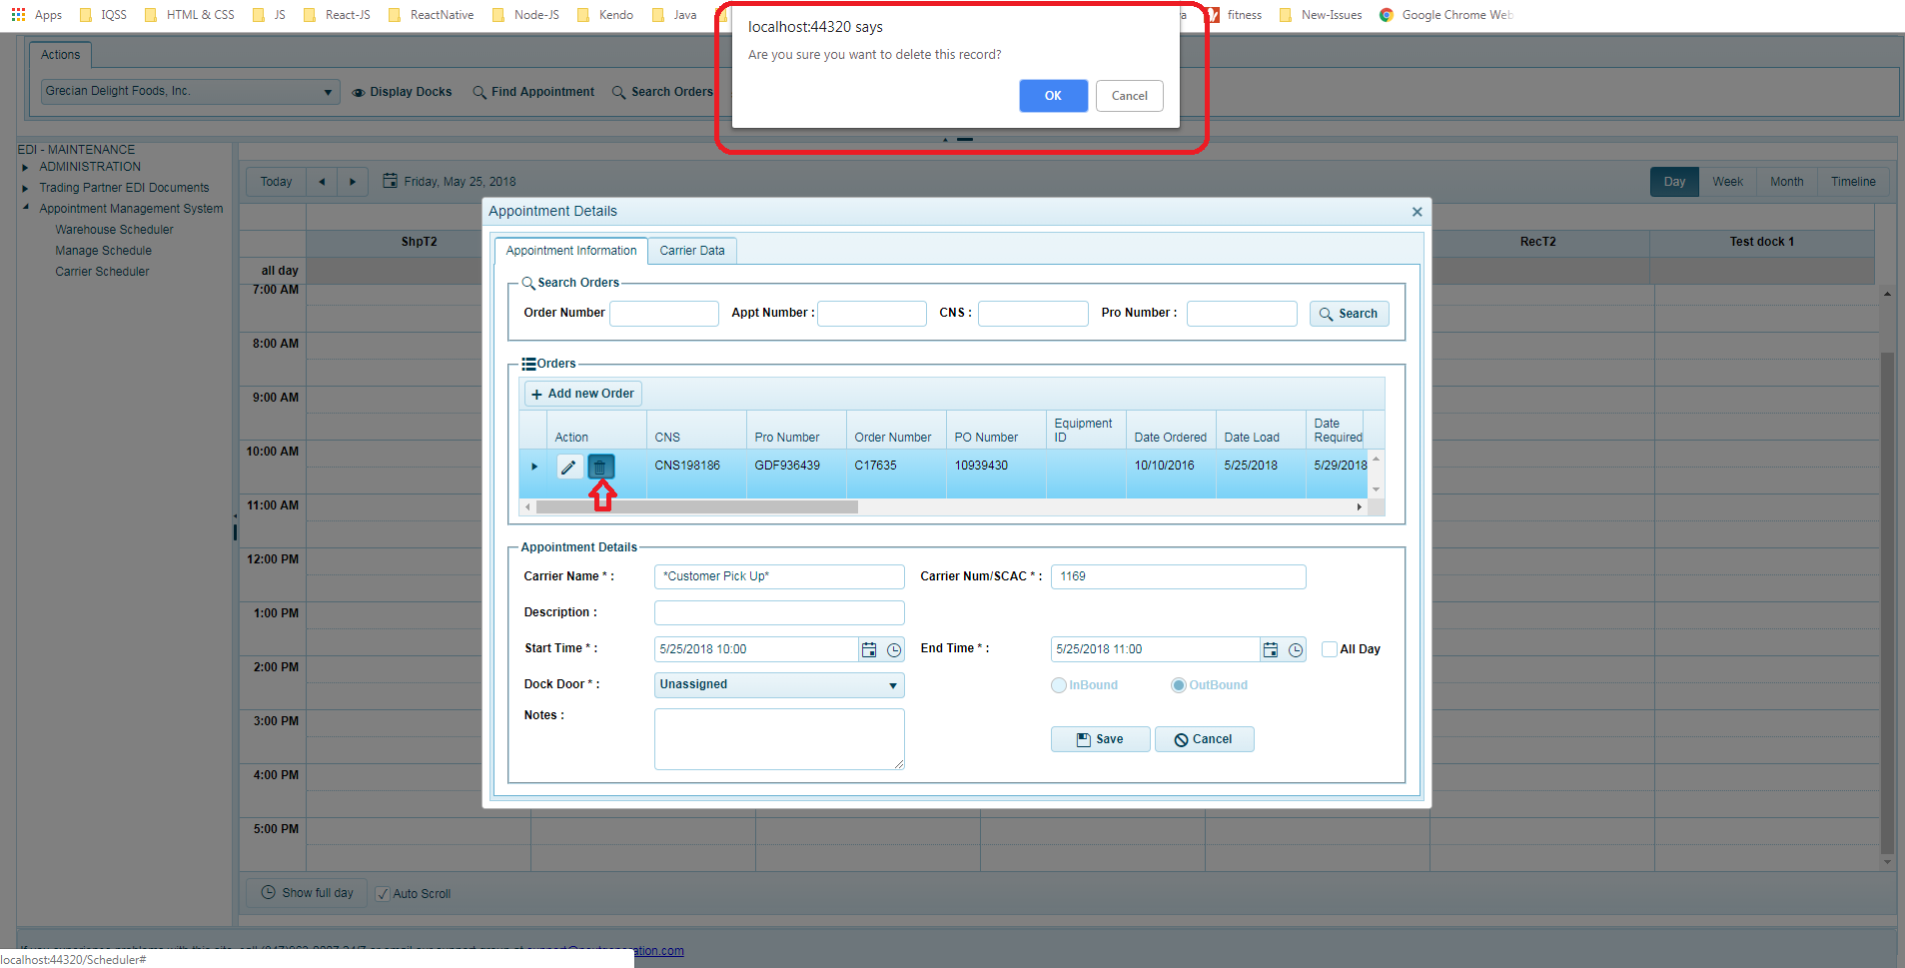

1. The orders available in the orders grid those will be added to that particular appointment when the appointment details are saved.

**Orders Details**

The items in a particular order and details can be seen by clicking on “Expand” button i.e. arrow icon available to the left of each orders row, to view orders Items as seen in the screenshot below.

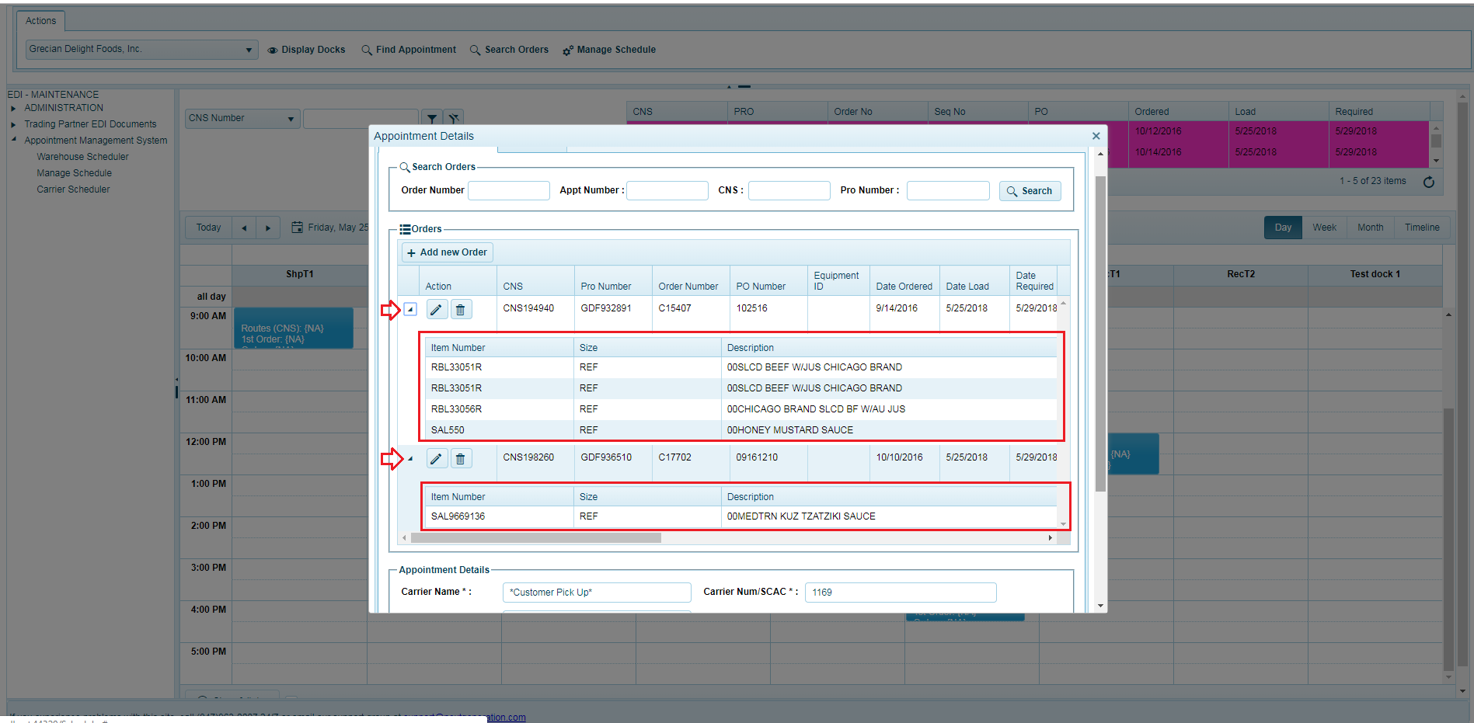

**Carrier Data Tab**

1. The carrier data tab displays the audit data of the order pick up, delivery etc. with the update fields that can be updated.
2. Carrier data tab contains 3 sub sections for the appointment as Appointment Details, Tracking Fields and User Fields as seen in the screenshot below:

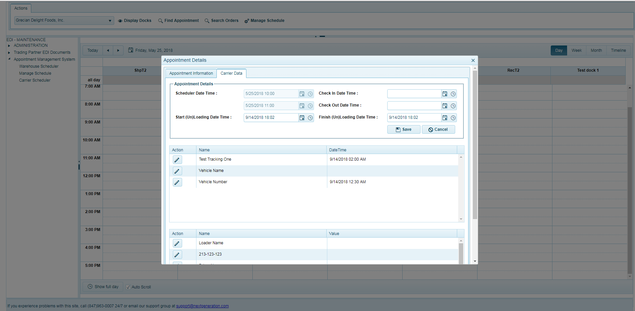

1. The appointment details section provides the appointment details such as scheduling date, check-in, checkout, start & finish load dates.
2. The user can add and update the dates as per the need in an appointment by editing and clicking “Save” button.
3. The Tracking Fields section is an grid which allows to update the dates of an tracking fields by clicking the edit  button available in each row of the grid.
4. The user Fields section allows to update details of user fields by clicking the edit  button available in each row of the grid.

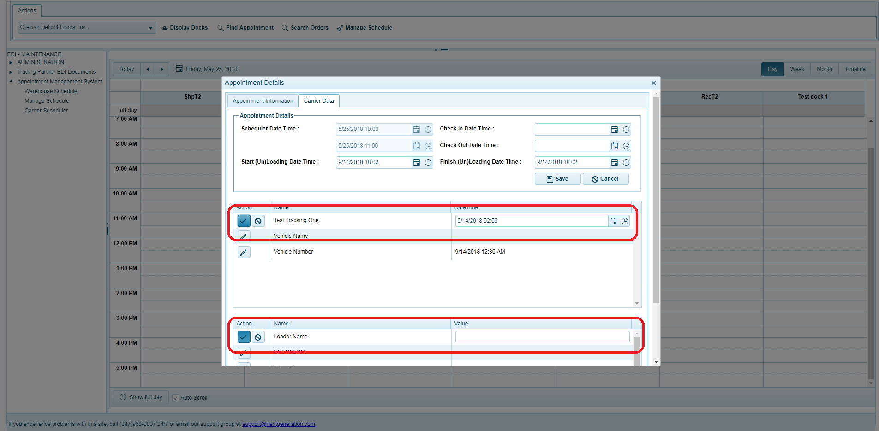

* 1. **Override Appointments**

The override appointment option is a feature available in the system to override the validation and proceed with the changes or scheduling an appointment. Only authorized users having privileges will be able to override and schedule or save appointment details.

The overrides window is shown when an appointment is not saved or not updated due to the validation failure. The user gets an override window with the response displaying the failure message

Some failures reasons are:

1. The maximum allowed appointments per day have been met
2. Exceeds the minimum or maximum time period of the Appointment for the Dock Doors
3. Orders may not supported for that dock Doors

In the any of the above reason the Override popup with message will be displayed as seen in screenshot below:

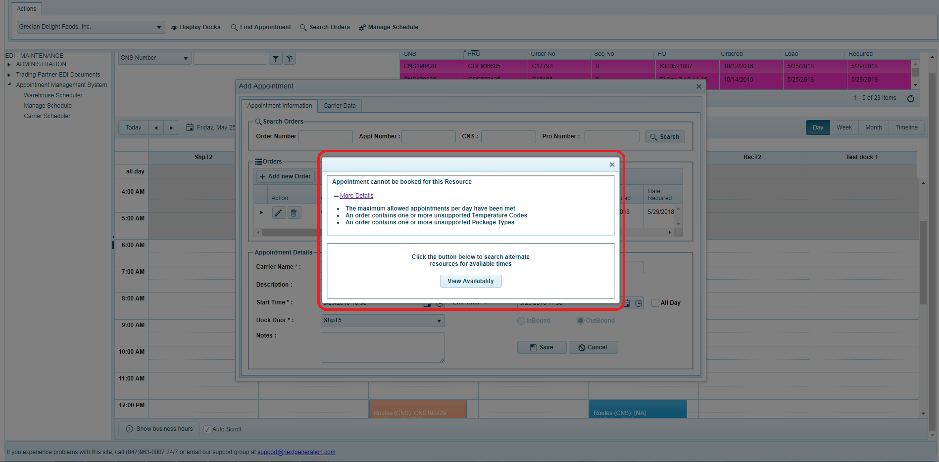

The override window provides the options based on the dock door override settings and it is displayed when the override settings is active/allowed otherwise it will not display the window.

If the Override settings is set to ON, the popup shows the override message and the user can override the Dock Door settings if the dock door provides an override options with “Override password” and “Reason Code”

The “Override password” input field to enter the password and selecting the “Reason Code” will be displayed in the Override Appointment window as seen in the screenshot below:

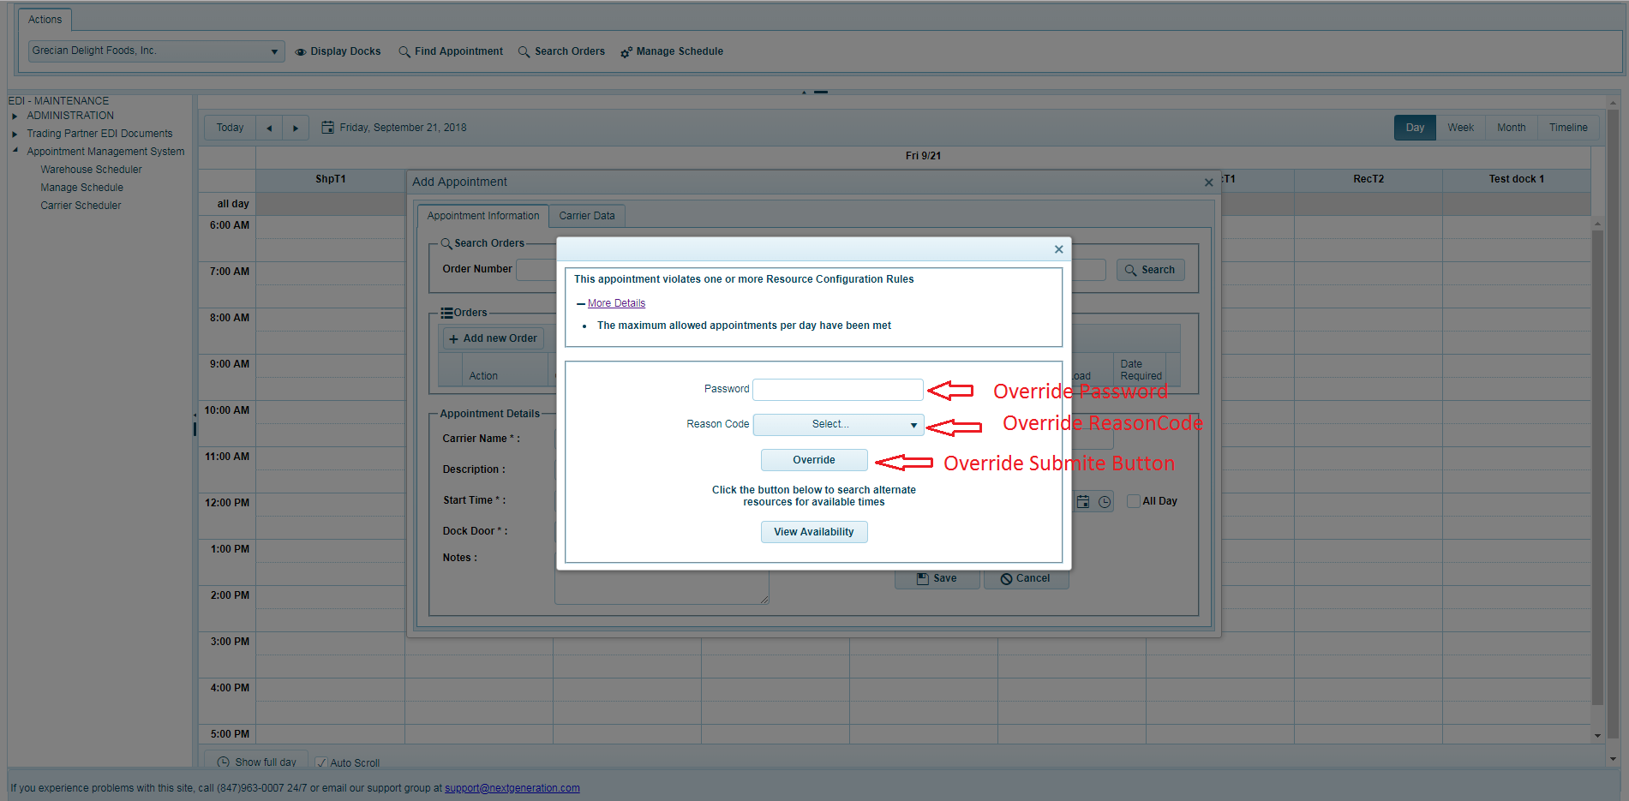

The override window also has “View Availability” button which allows to search available appointments for a selected orders by clicking on “view Availability” button to view and Book an Appointment for an Orders from the appointments list (if available) as seen in the screenshot below.

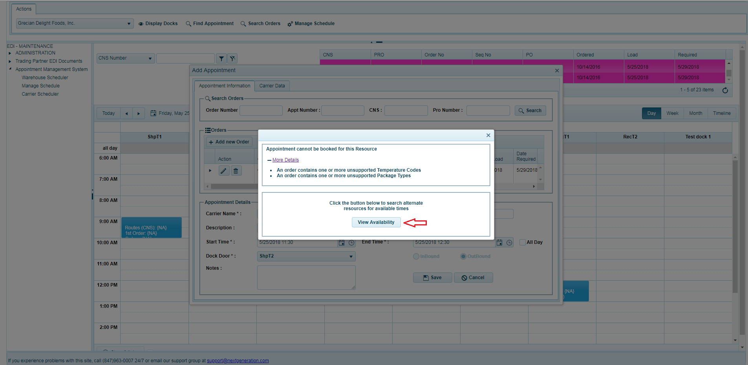

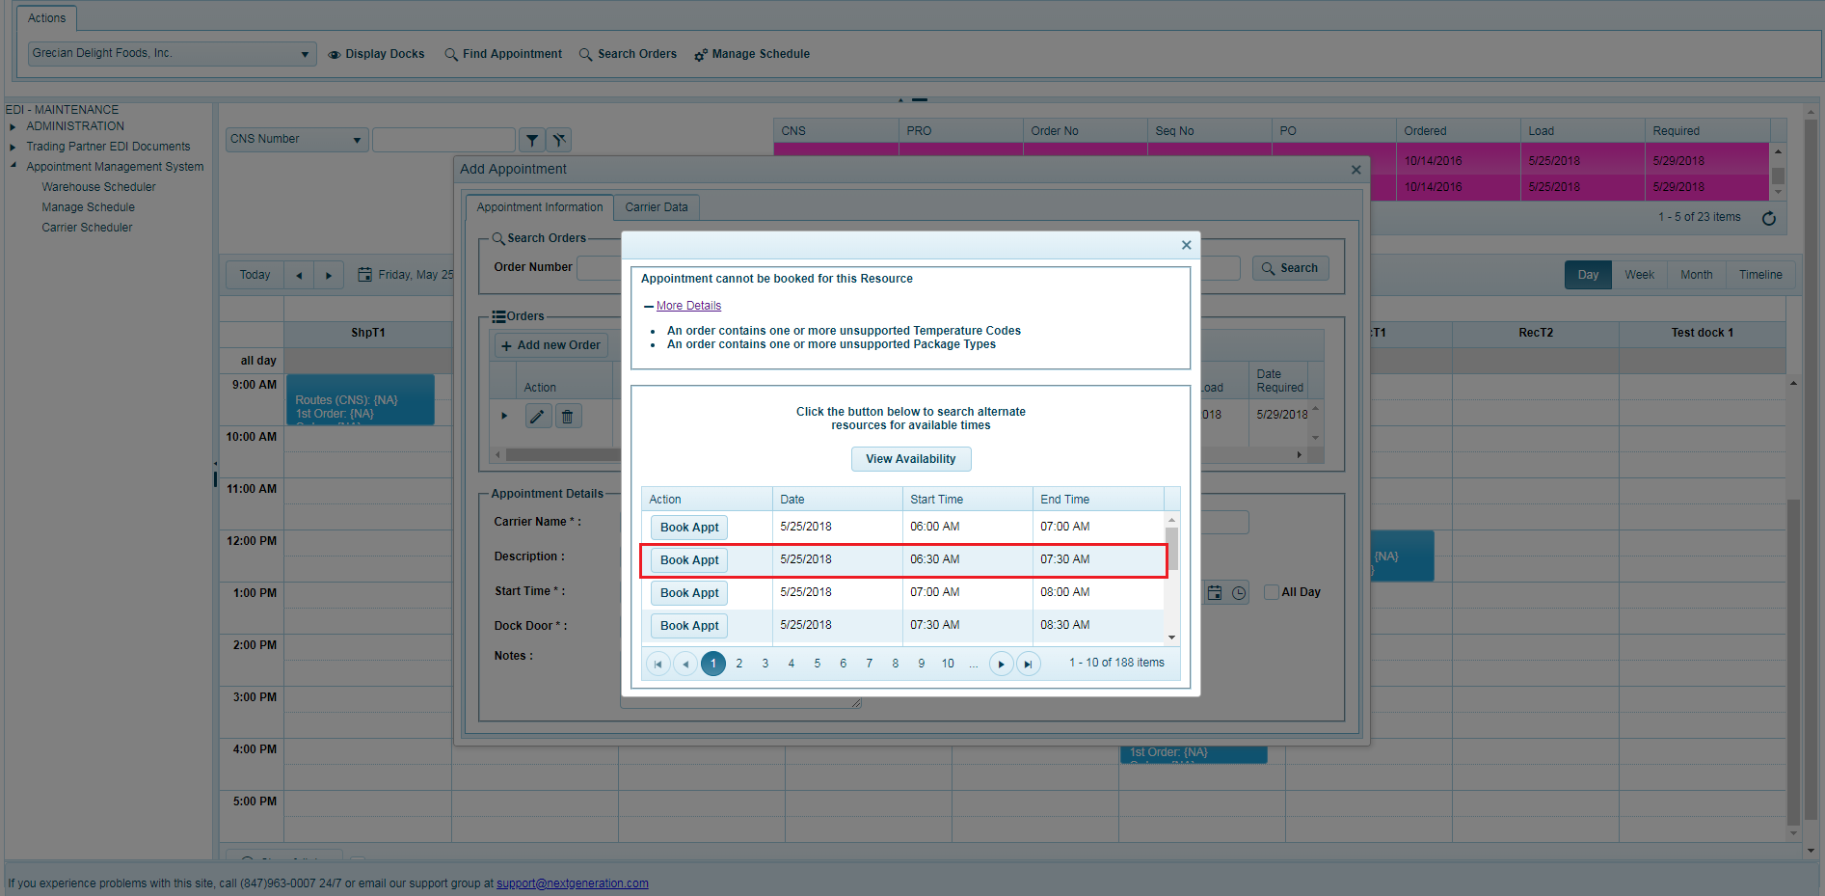

Once the available appointment list displays appointments, the user can select one of the appointment from the list i.e. based on the dock door and the time period of the and click on that particular row of an Action button “Book Appointment”.

# Administration - Manage Schedule

The administration section - Manage Schedule page enables to the user with admin privileges to setup, configure and manage settings of ware house along with dock doors etc.

The Manage Schedule page allows the user to manage the Scheduler settings for the warehouses and the dock doors along with other settings of the warehouse.

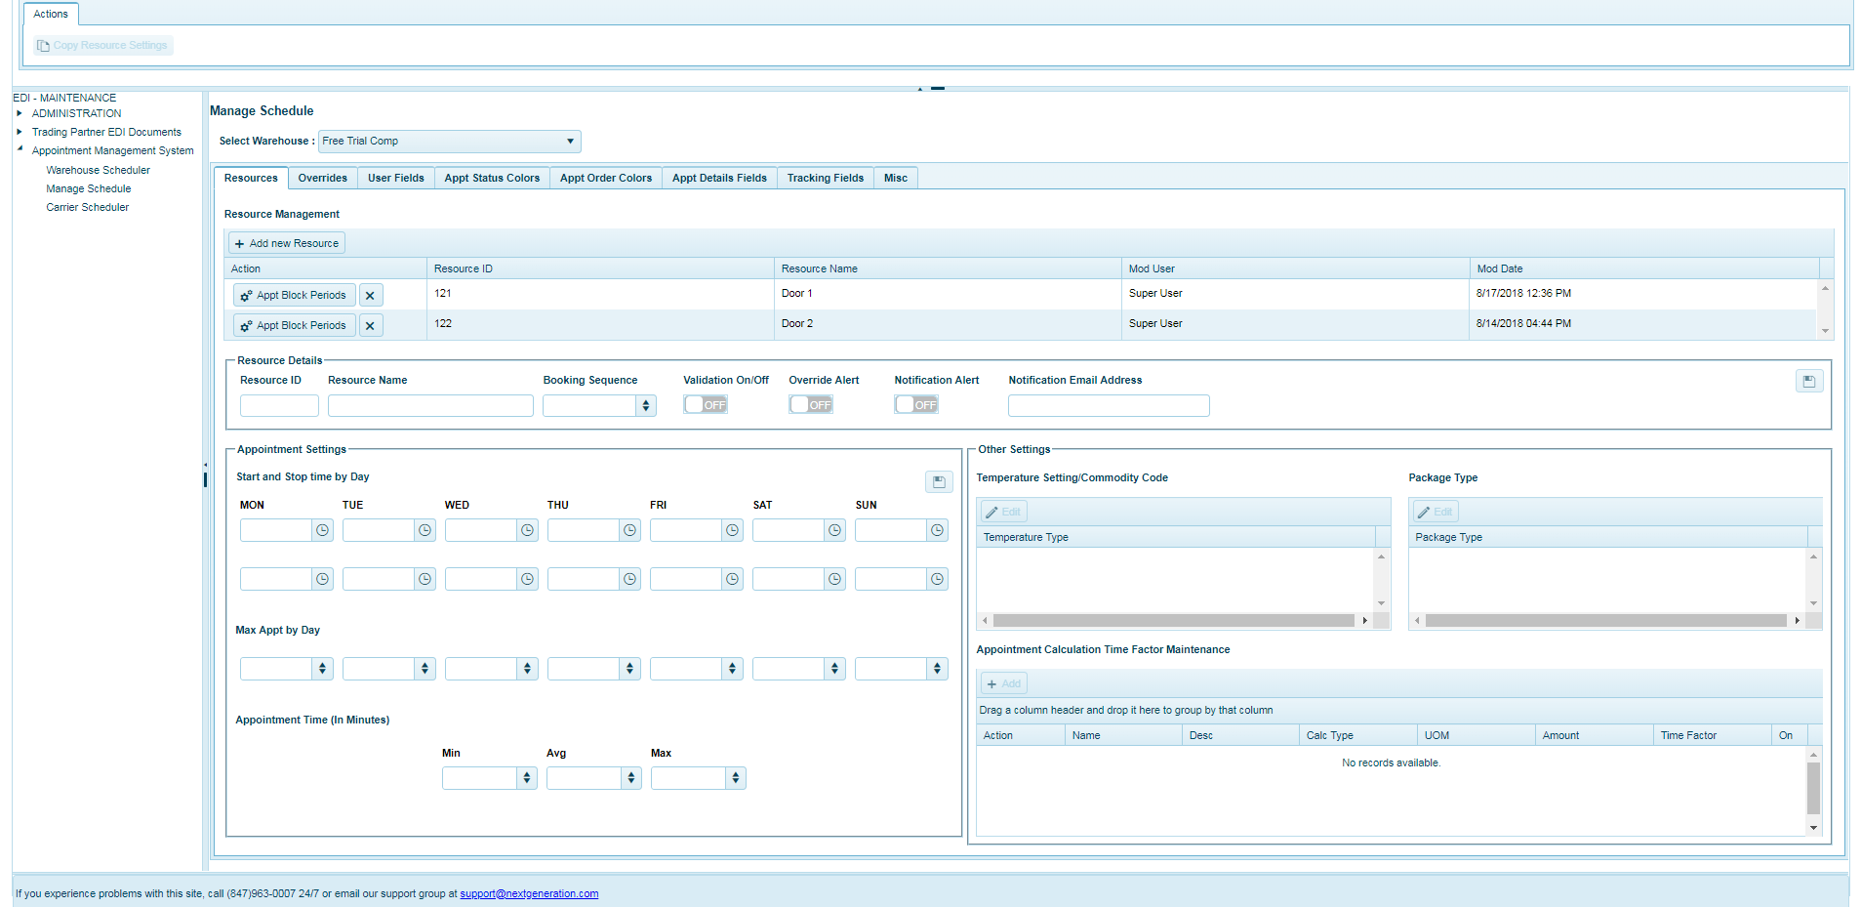

2.1.1. **Resource (Dock Door) Configuration**

The resource or dock doors of warehouse can be setup and managed from this page. This page allows adding a new dock door along with setting details of start & end timing, pallet type & temperature type supported by dock door and other configuration.

**Add Resource**

1. A new resource can be added to the selected warehouse by clicking on “+Add new resource” button available in the resource grid tool bar.
2. Add new resource popup window is displayed on clicking the button as seen in the screenshot below.
3. The popup window allows the admin to input the required details and click on save button to add the new resource for selected warehouse or the admin can click close popup button to cancel adding a new resource.

**Fields:**

|  |  |  |
| --- | --- | --- |
| **Sl.no** | **Fields Name** | **Details** |
| 1 | Resource ID | Required : Mandatory  Data Type : Alphanumeric |
| 2 | Resource Name | Required : Mandatory  Data Type : Alphanumeric |
| 3 | Booking Sequence | Required : Optional |
| 4 | Validation On/Off | Required : Optional |
| 5 | Override Alert | Required : Optional |
| 6 | Notification Alert | Required : Optional |
| 7 | Notification Email | Required : Optional |

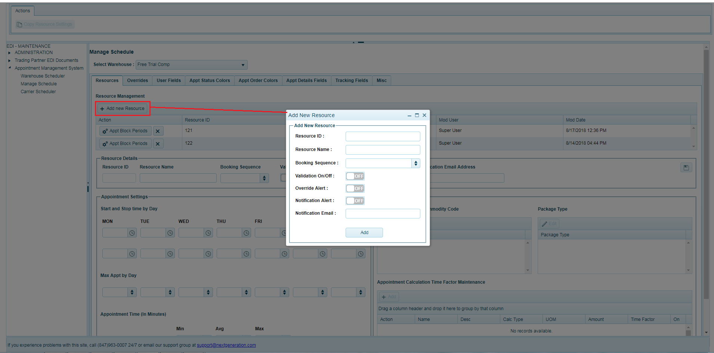

**Delete Resource**

1. A resource can be deleted from the resources list of the selected ware house by clicking on Delete  button available in Actions column of each resource row in the list.
2. A confirmation dialog box will be displayed asking the admin to confirm deletion of the resource
3. Click “OK” to delete or “Cancel” to cancel deleting the resource

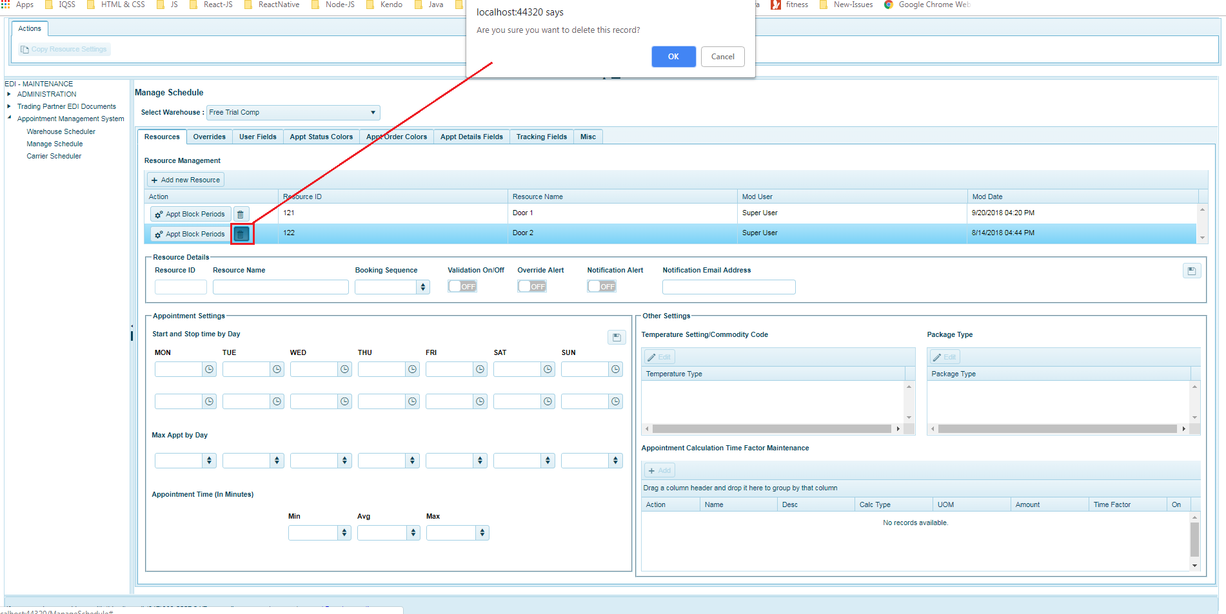

2.1.2 **Copy Resource Settings**

1. Copy resource settings enables the admin to
   1. Copy resource settings from an existing resource to a new resource
   2. Overwrite the resource settings from an existing resource by copying settings from another resource
2. When clicked on “Copy resource Settings” button the admin has to select any one of the resource in the resources list and once the button is clicked, the popup opens as seen in the screenshot below.

**New resource**

1. Copy the resource settings for the new resource by entering the new ‘Resource ID’ and ‘Resource Name’
2. Once the ‘Resource ID’ and ‘Resource Name’ is entered, admin can click on “Add Resource and Copy Settings” button for create the new resource and copying the settings.
3. User can override the settings of an existing resource by selecting another existing resource to the copy settings.

**Fields:**

|  |  |  |
| --- | --- | --- |
| **Sl.no** | **Fields Name** | **Details** |
| 1 | Resource ID | Required : Mandatory  Data Type : Alphanumeric |
| 2 | Resource Name | Required : Mandatory  Data Type : Alphanumeric |

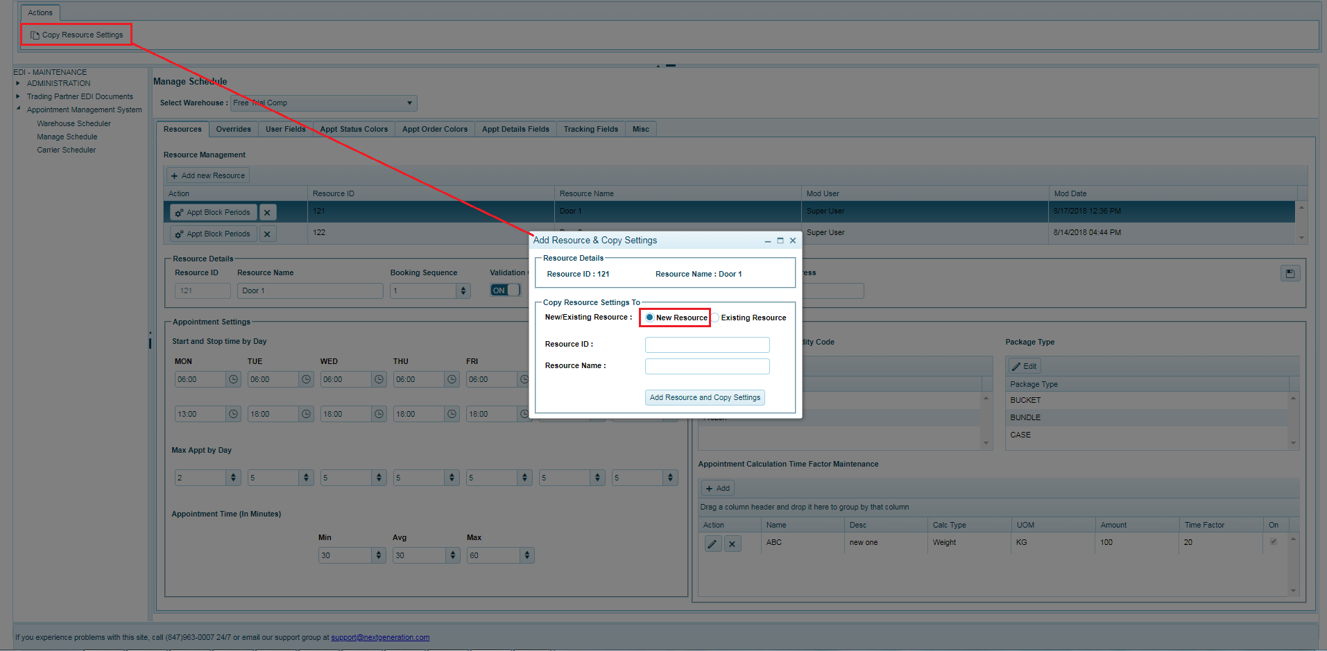

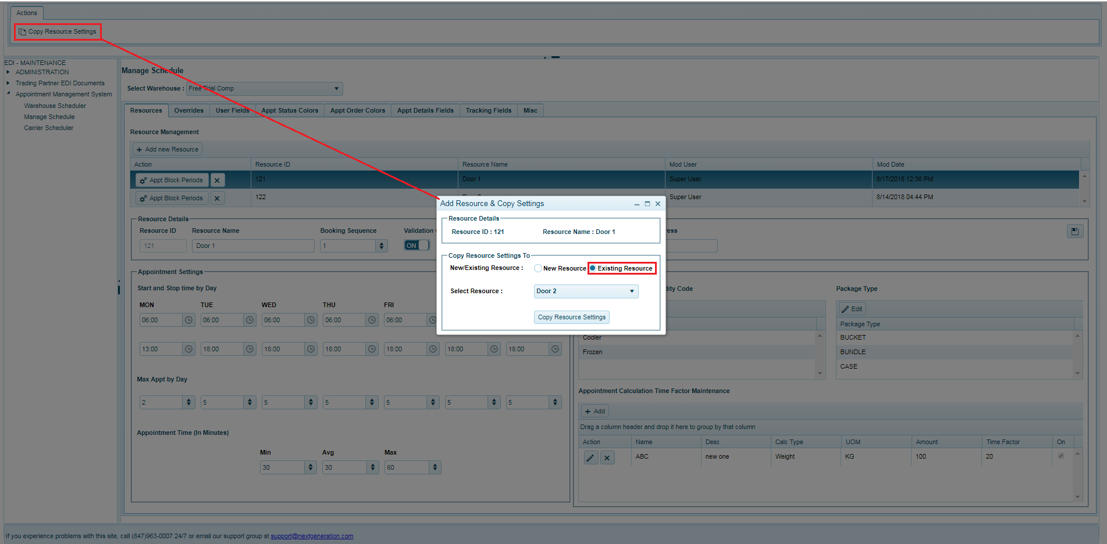

2.1.3 **Edit Resource Details and settings**

* 1. The admin can edit the resource details and settings by selecting the resource from the resources grid
  2. Once a resource is selected, the resource the details are displayed in resource details section along with the settings in appointment Settings section as seen in the screenshot below.
  3. Once the details are edited and setting of an resource, admin can save the details in the appropriate section available at the top of each sub section by clicking the  (save) button respectively.

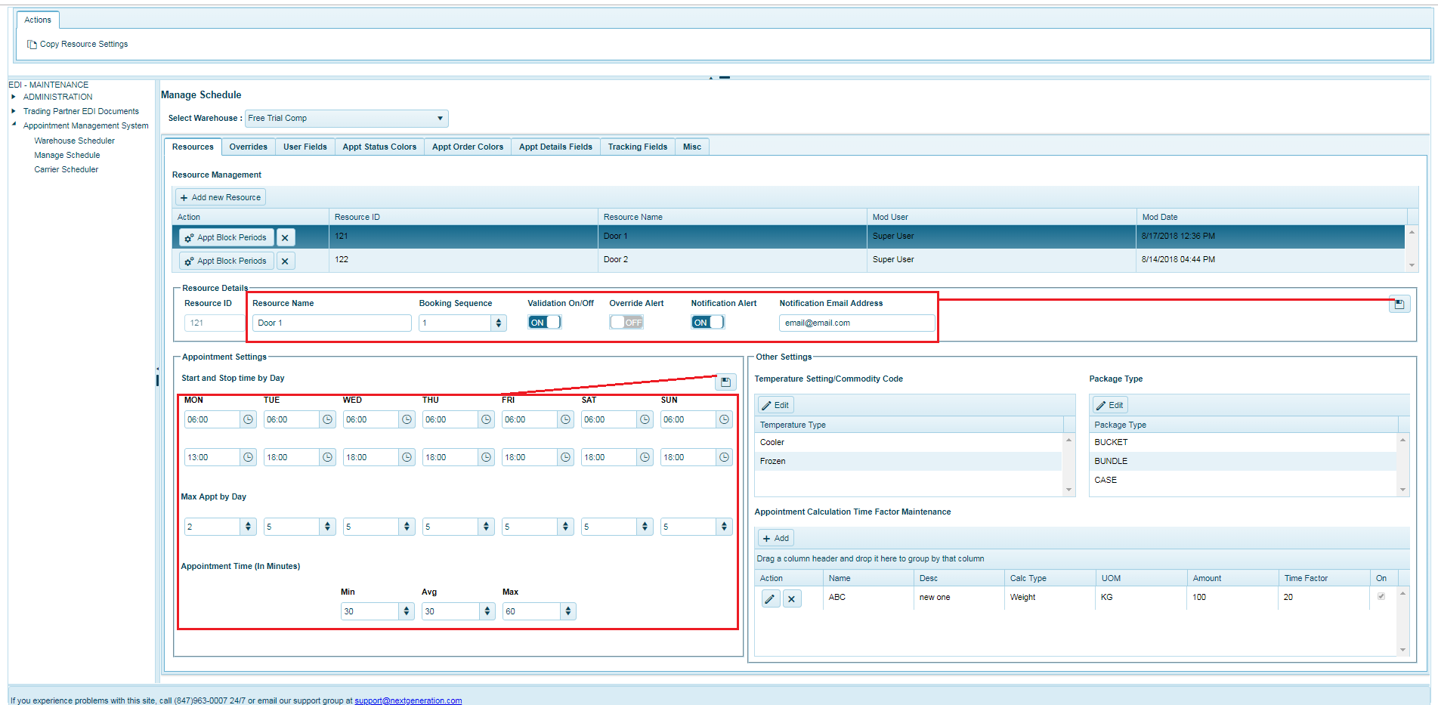

2.1.4 **Edit Resource Other settings**

2.1.4.1 **Package Types**

1. The package types supported type by particular resource can also be setup by clicking on edit  button available in the toolbar of package Type list grid.
2. The admin can click on edit button for the popup window to open and list the package types so that admin can select the package type supported.
3. The selected package types are associated to the resource once the admin clicks on “save” button to save the changes or click to close popup button to cancel the selected Package types.

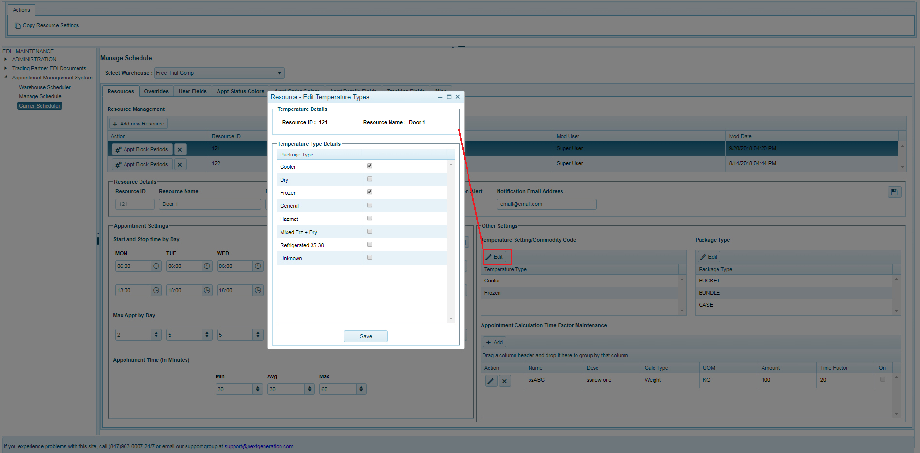

2.1.4.2 **Temperature Types**

1. The temperature types for a resource can be setup and managed by clicking the edit  button available in top header of Temperature Type list grid.
2. Admin can click on edit button to open the popup window listing the temperature type so that the supported temperature type can be selected from the grid.
3. Once the admin has completed selecting the temperature types to be associated they can click on “save” button to save the changes or click to close popup button to cancel the chosen temperature types.

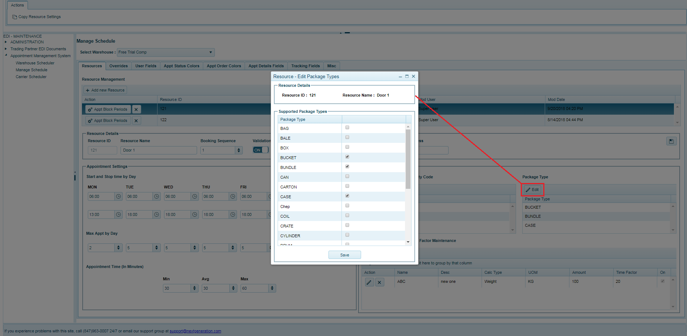

2.1.4.3 **Appointment calculation time factor**

**Add Appointment calculation time factor**

1. Admin can add a new Appointment calculation time factor an resource by clicking “+Add” available in top header of appointment calculation time factor grid.
2. When the button is clicked the popup window opens allowing to enter details of the Appointment calculation time factor as seen in the screenshot below.
3. Once the details are entered, admin should click “save” button to add the new Appointment calculation time factor or user can close the popup button to cancel adding the new Appointment calculation time factor.

**Fields:**

|  |  |  |
| --- | --- | --- |
| **Sl.no** | **Fields Name** | **Details** |
| 1 | Name | Required : Mandatory  Data Type : Alphanumeric |
| 2 | Description | Required : Optional |
| 3 | Calc Type | Required : Optional |
| 4 | Unit of Measure | Required : Optional |
| 5 | Amount | Required : Optional |
| 6 | Time Factor | Required : Optional |
| 7 | On | Required : Optional |

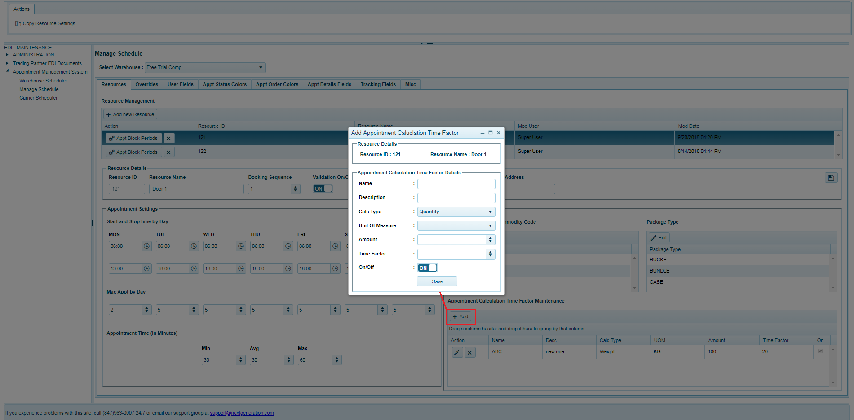

**Edit Appointment calculation time factor**

1. The user can edit details of an existing appointment calculation time factor by clicking on edit  button available for each appointment calculation time factor in the list.
2. Admin can click on edit button for the popup to open in edit mode as seen in the screenshot below.
3. Once the details are modified, the user should click on “save” button to save the changes or close popup to cancel the changes.

**Fields:**

|  |  |  |
| --- | --- | --- |
| **Sl.no** | **Fields Name** | **Details** |
| 1 | Name | Required : Mandatory  Data Type : Alphanumeric |
| 2 | Description | Required : Optional |
| 3 | Amount | Required : Optional |
| 4 | Time Factor | Required : Optional |
| 5 | On | Required : Optional |

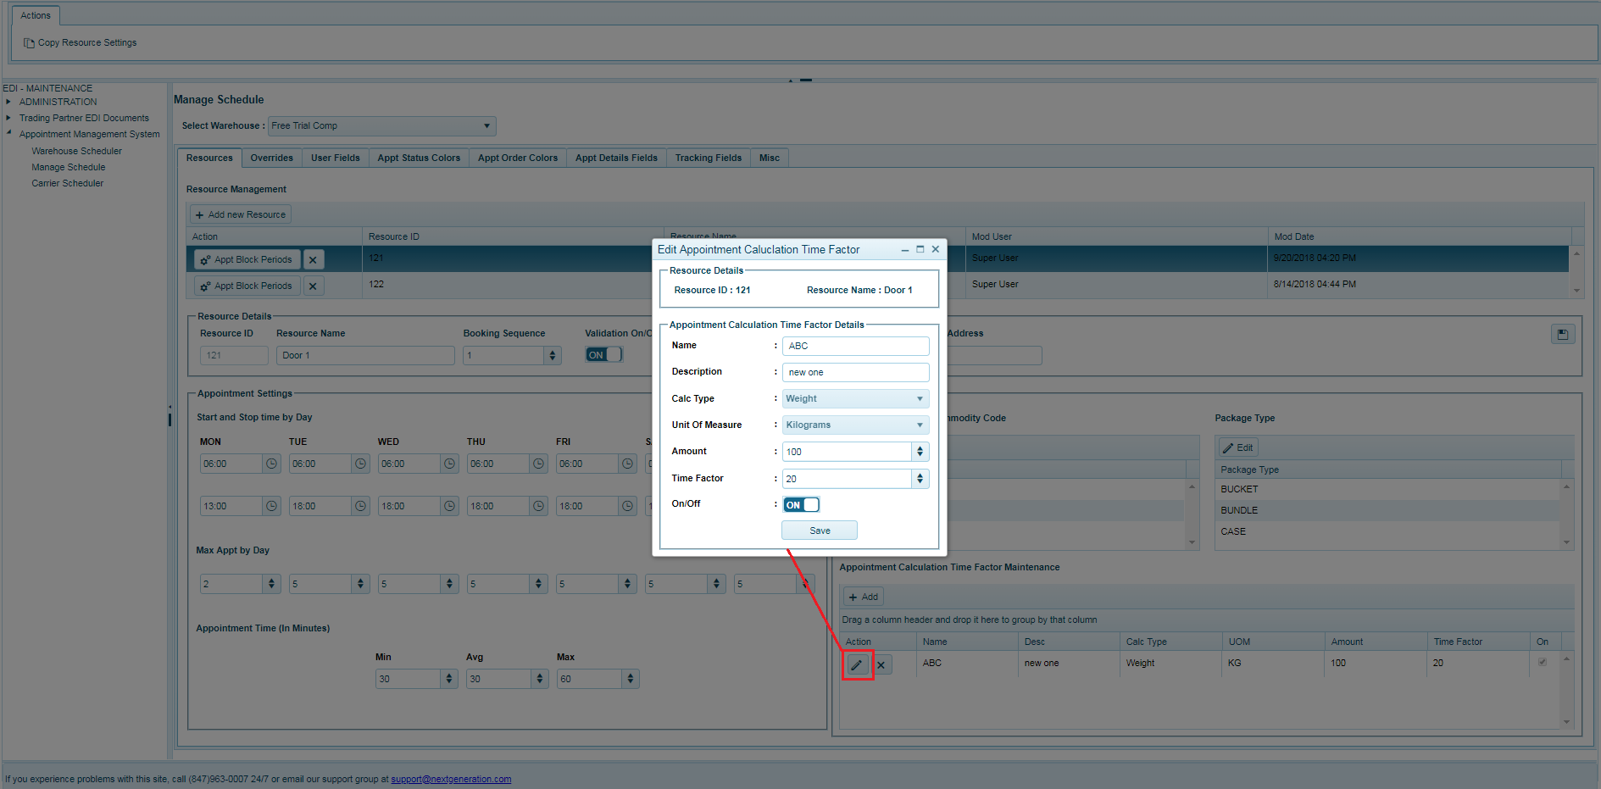

**Delete Appointment calculation time factor**

1. The user can delete an appointment calculation time factor by clicking on Delete  button available in action column of each row in the list.
2. A confirmation dialog box is be displayed asking the user to confirm deletion of the record.
3. Click “OK” to delete or “Cancel” to cancel deleting the row.

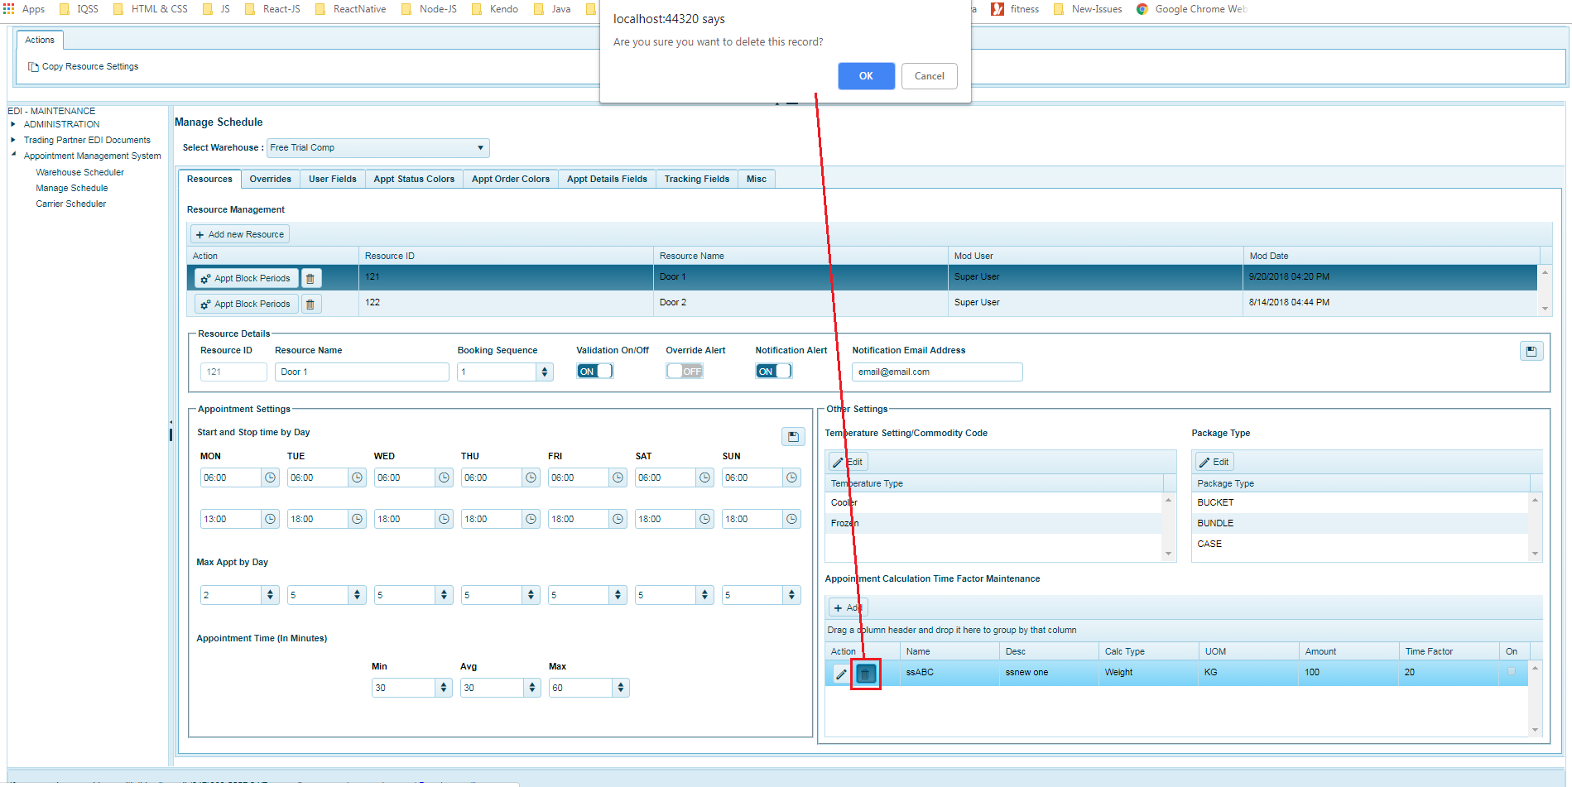

2.2 **Overrides**

Override tab allows the admin to setup and configure the override settings for the resources after selecting a resource from the resources dropdown list.

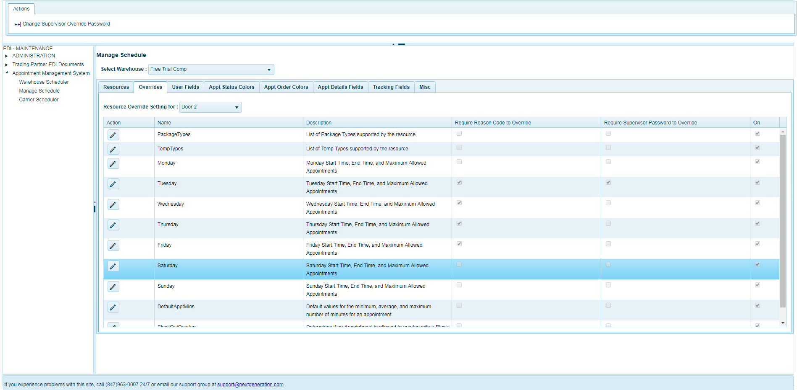

**Edit override settings**

1. The admin can edit override settings of a resource by clicking on edit  button available in each override setting in the override settings list.
2. They can click on edit button to edit relevant override settings by clicking on edit button available in left pane for each row in the list.
3. Once the Settings are edited, the user can make necessary and click on save  button to save the changes or click cancel  button to cancel the change settings.

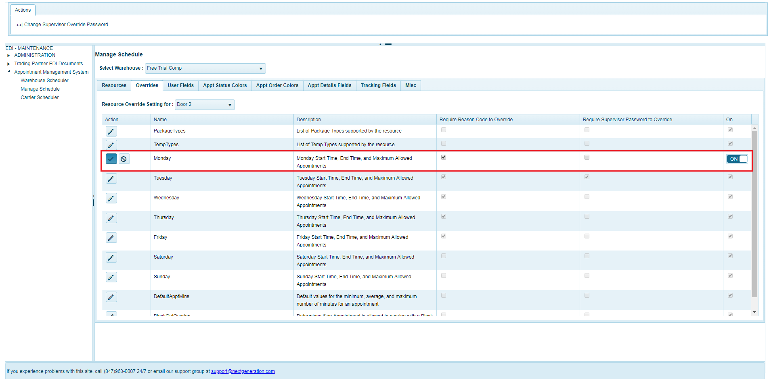

**Change supervisor override password**

1. Admin can edit/change Supervisor Override Password by clicking on “Change Supervisor Override password” available in the Action tab.
2. When the button is clicked the change supervisor override password popup open up for that selected resource In the dropdown as seen in the screenshot below.
3. The admin should enter the ‘new Password’ and ‘Confirm New Password’ user and click “Change Password” button to save or update the password or close the popup to cancel updating the password.

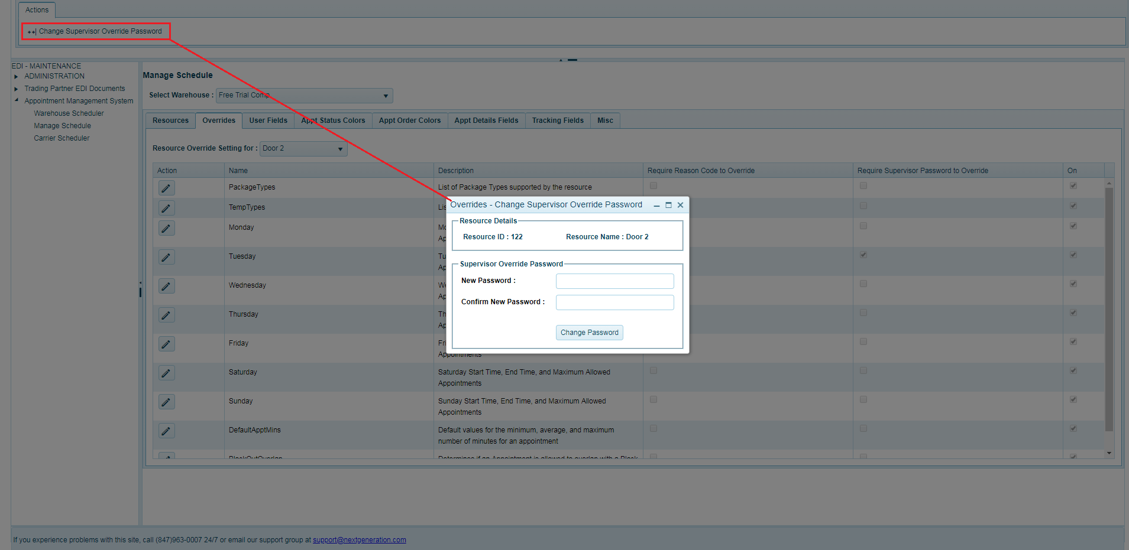

2.3 **User Fields**

1. User Fields section allows the user to setup and manage user fields in the system.
2. These are fields that can be setup to capture the details and track the details as part of the appointment details.
3. The user fields are displayed in the Carrier Data tab of the appointment details in the scheduler module.
4. The admin can setup new user field and manage existing user field from this tab of the page.

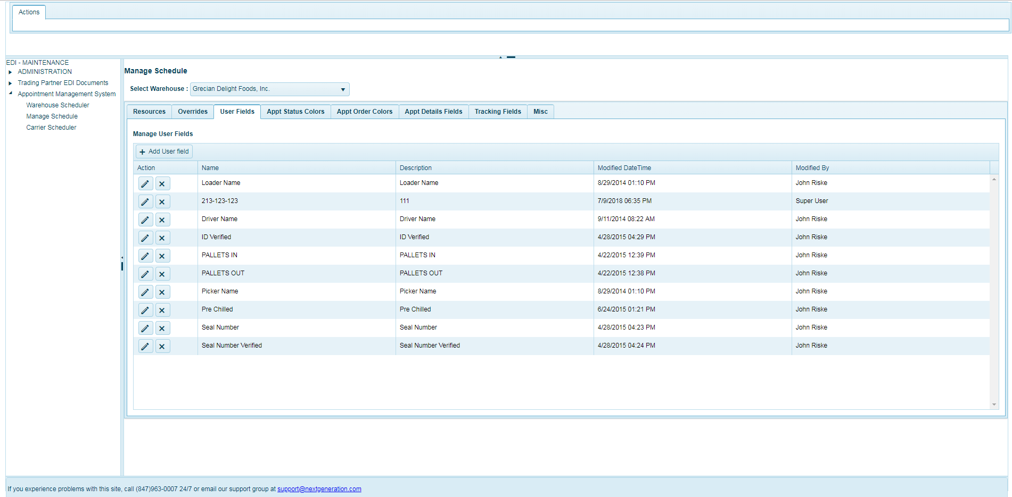

**Manage User Fields User Fields**

1. The admin can add a new user field for an warehouse by clicking “+Add User Field” available in Top Toolbar of the User Fields grid
2. When the button is clicked the grid that displays the new row with two input fields named as ‘Name’ and ‘Description’ as seen in the screenshot below.
3. Once the details are entered, user should click save  button to add the new User Field or they can click clear  button to cancel adding the new User Field.
4. The admin can edit details of an existing user field by clicking on edit  button available in each row of user fields list.
5. They can click on edit button that needs to be edited in left pane, the columns will be displayed in edit mode allowing to modify details.
6. Once the details are modified, the admin should click on save  button to save the changes or click cancel  button to cancel the changes.

**Fields:**

|  |  |  |
| --- | --- | --- |
| **Sl.no** | **Fields Names** | **Details** |
| 1 | Name | Required : Mandatory  Data Type : Alphanumeric |
| 2 | Description | Required : Optional |

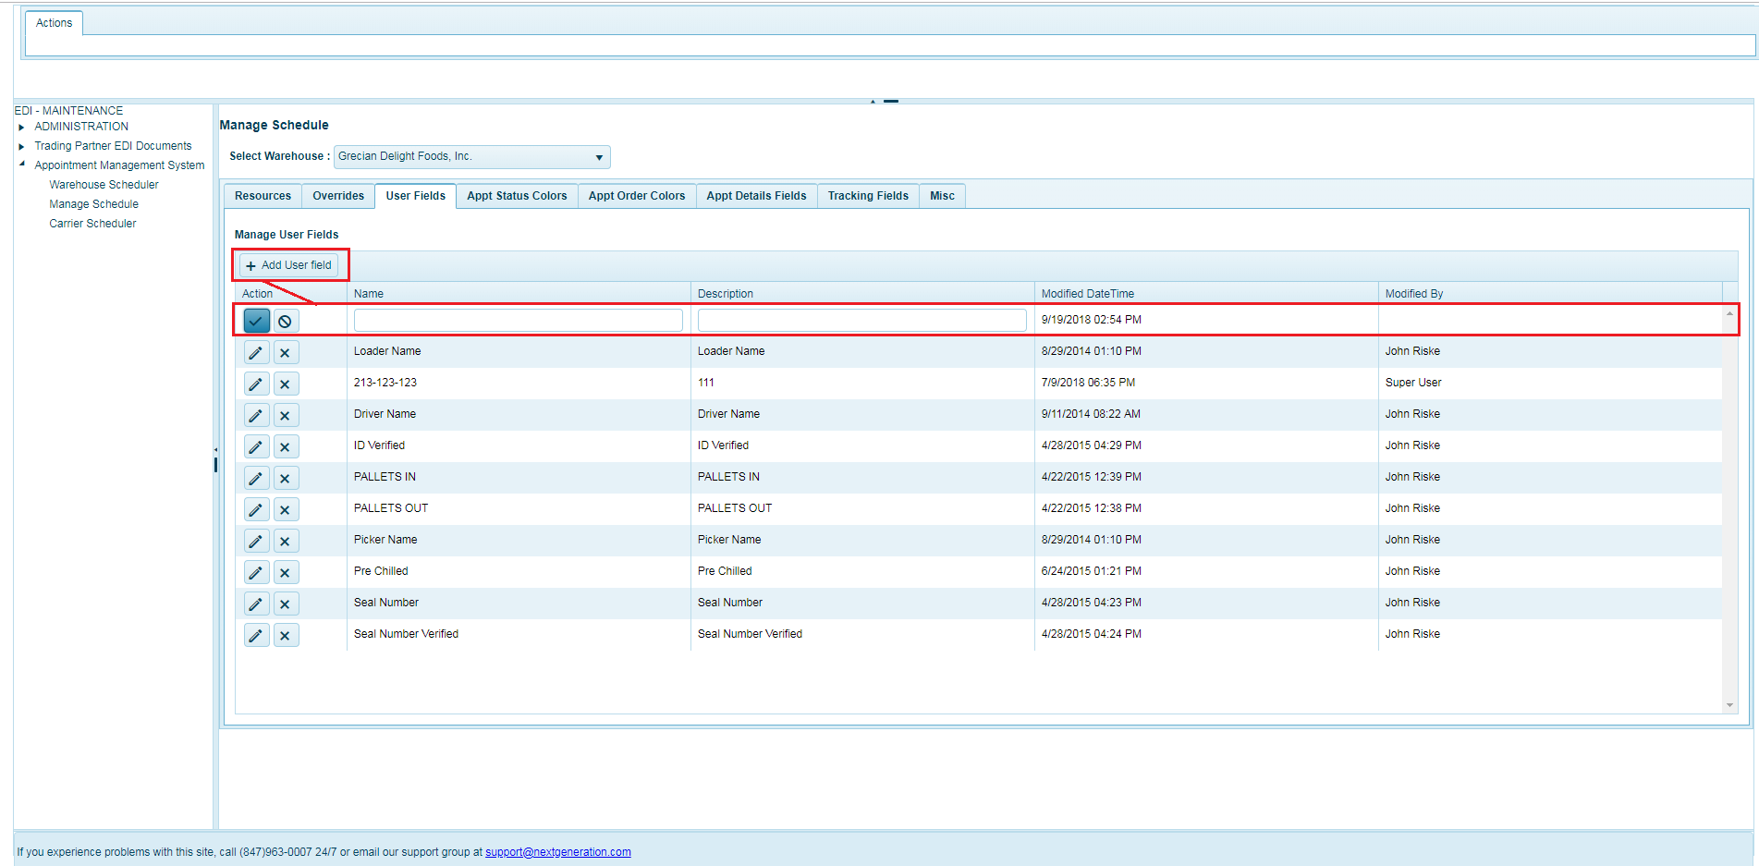

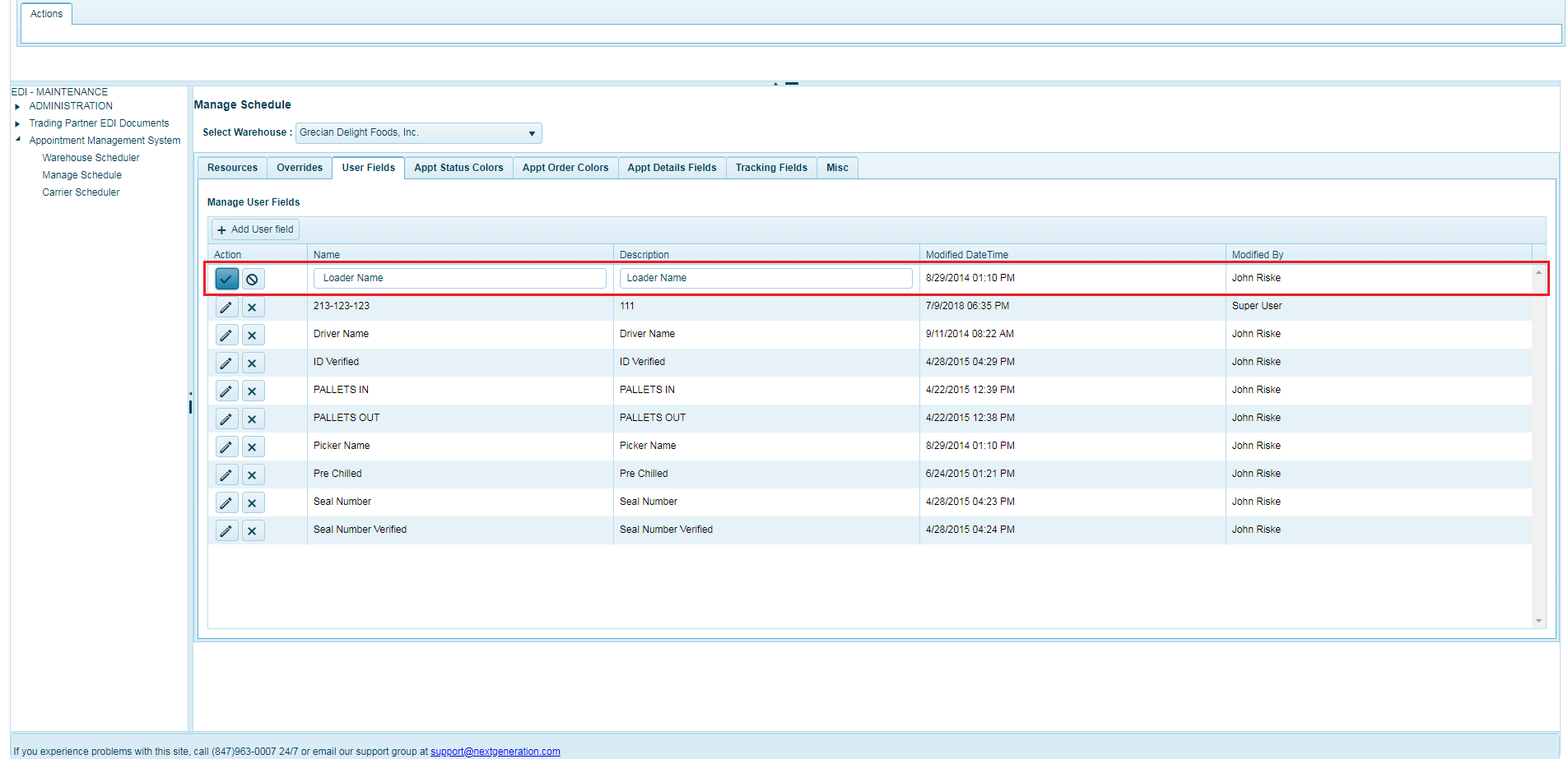

**Delete User Fields**

1. The admin can delete a user field by clicking Delete  button on the particular user field row that needs to be deleted from action column in the list.
2. A confirmation dialog box will be displayed asking the user to confirm deletion of the record.
3. Click “OK” to delete or “Cancel” to cancel deleting the row.

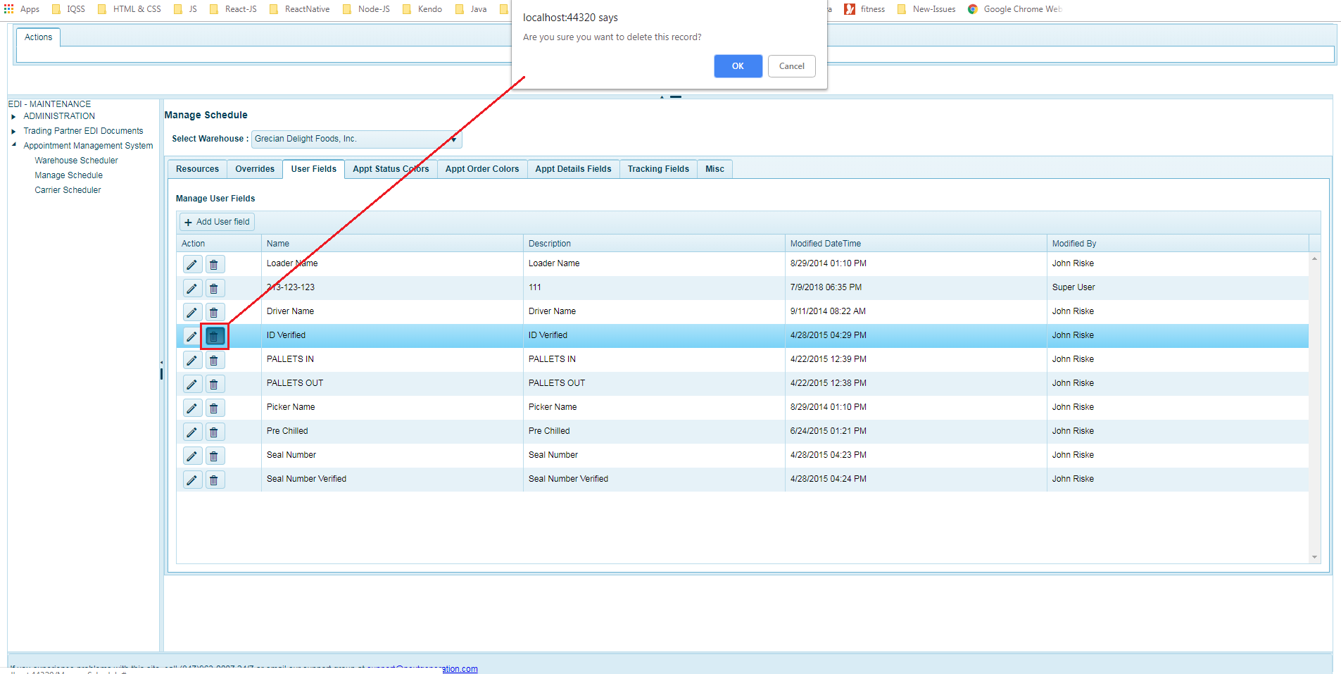

2.4 **Appointment Status Colour**

Appointment Status Colour section allows the user to add, edit and delete appointment status colour for the selected warehouse.

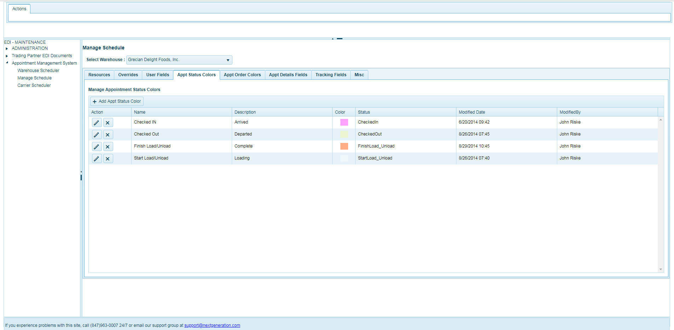

**Add Appointment Status Colour**

1. Admin can add a new appointment status colour for the warehouse by clicking on “+Add Appt Status Colour” available in the top toolbar of appointment status colour grid.
2. When the button is clicked the grid displays the new row with input fields as seen in the screenshot below .
3. Once the details are entered, admin should click save  button to add the new appointment status colour or they can click clear  button to cancel adding the new appointment status colour.

**Fields:**

|  |  |  |
| --- | --- | --- |
| **Sl.no** | **Fields Name** | **Details** |
| 1 | Name | Required : Mandatory  Data Type : Alphanumeric |
| 2 | Description | Required : Optional  Data Type : Alphanumeric |
| 3 | Colour | Required : Optional |
| 4 | Status | Required : Mandatory |

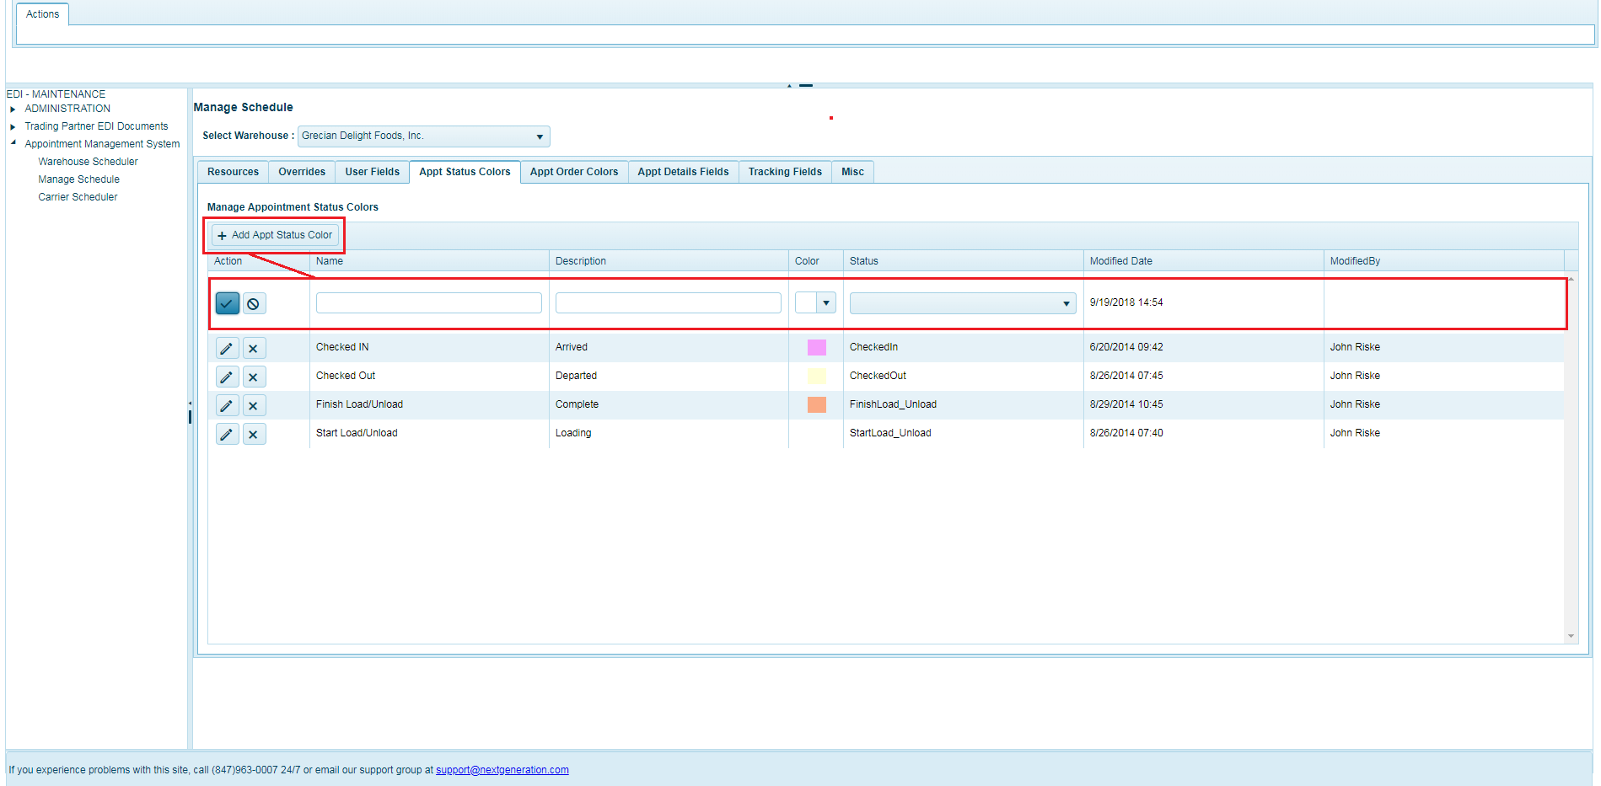

**Edit Appointment Status Colour**

1. The admin can edit details of an existing appointment status colour by clicking on edit  button available in each row of appointment status colour list.
2. They can click on edit button that needs to be edited in left pane the columns will be displayed in edit mode to modify details.
3. Once the details are modified, the user should click on save  button to save the changes or click cancel  button to cancel the changes.

**Fields:**

|  |  |  |
| --- | --- | --- |
| **Sl.no** | **Fields Name** | **Details** |
| 1 | Name | Required : Mandatory  Data Type : Alphanumeric |
| 2 | Description | Required : Optional  Data Type : Alphanumeric |
| 3 | Colour | Required : Optional |
| 4 | Status | Required : Mandatory |

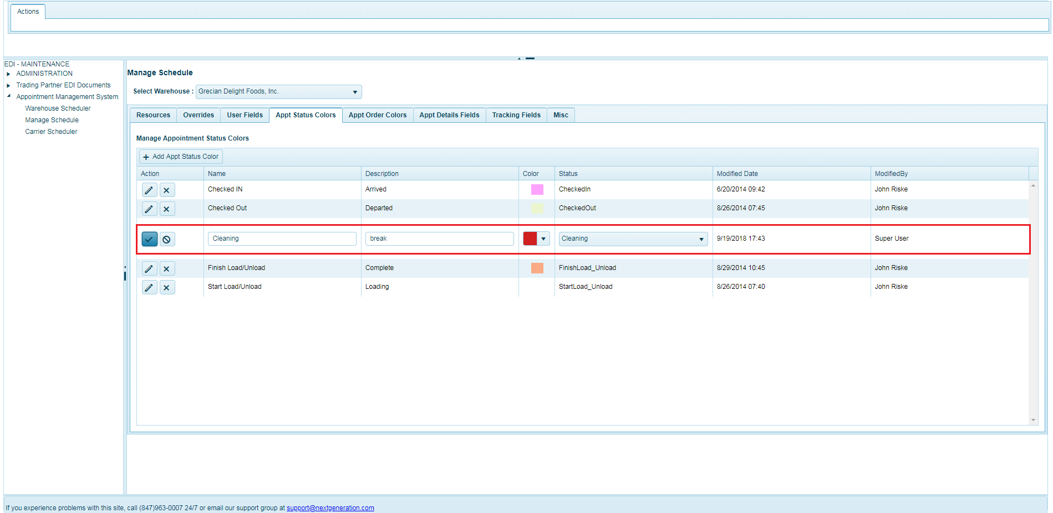

**Delete Appointment Status Colour**

1. The user can delete an appointment status colour by clicking on Delete  button on the particular row that needs to be deleted in the list.
2. A confirmation dialog box will be displayed asking the user to confirm deletion of the record.
3. Click “OK” to delete or “Cancel” to cancel deleting the row.

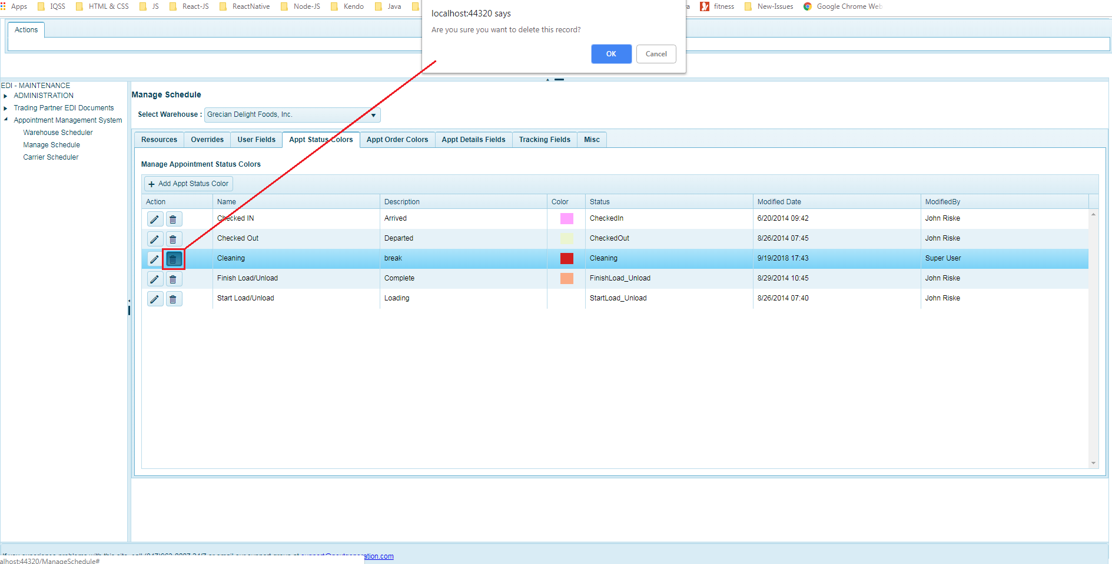

2.5 **Appointment Order Colour**

Appointment Orders Colour section allows the user to setup and manage appointment order Colour for the selected warehouse.

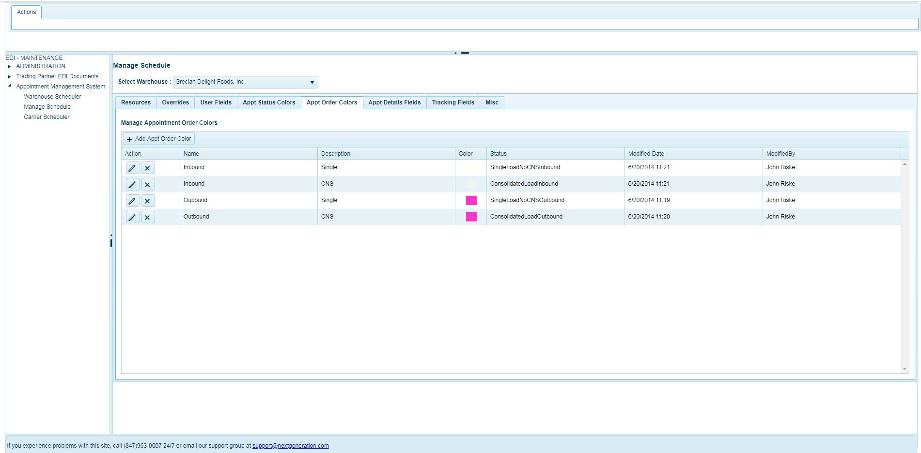

**Add Appointment Orders Colour**

1. Admin can add a new appointment orders colour for the warehouse by clicking on “+Add Appt Order Colour” available in the top toolbar of the grid.
2. When the button is clicked the grid is displays the new row with input fields as seen in the screenshot below.
3. Once the details are entered, admin should click save  button to add the new appointment orders colour or they can click clear  button to cancel adding the new appointment orders colour.

**Fields:**

|  |  |  |
| --- | --- | --- |
| **Sl.no** | **Fields Name** | **Details** |
| 1 | Name | Required : Mandatory  Data Type : Alphanumeric |
| 2 | Description | Required : Optional  Data Type : Alphanumeric |
| 3 | Colour | Required : Optional |
| 4 | Status | Required : Mandatory |

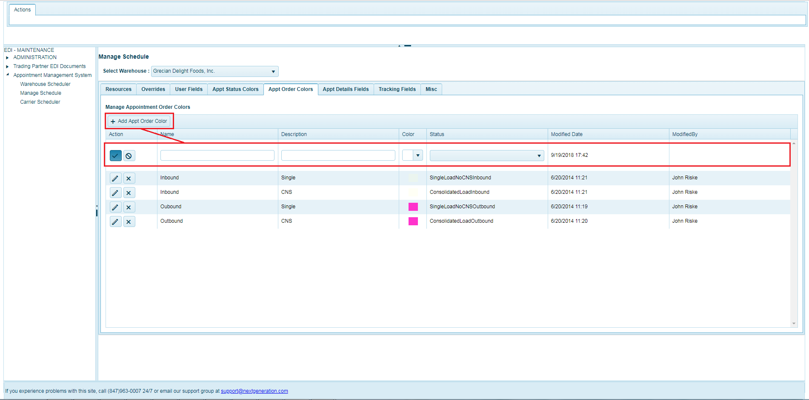

**Edit Appointment Orders Colour**

1. The user can edit details of existing appointment orders colour clicking on edit  button available in each row of appointment orders colour list.
2. They can click on edit button available in left pane on each row, the columns will be displayed in edit mode to modify the details.
3. Once the details are modified, the user should click on save  button to save the changes or click cancel  button to cancel the changes.

**Fields:**

|  |  |  |
| --- | --- | --- |
| **Sl.no** | **Fields Name** | **Details** |
| 1 | Name | Required : Mandatory  Data Type : Alphanumeric |
| 2 | Description | Required : Optional  Data Type : Alphanumeric |
| 3 | Colour | Required : Optional |
| 4 | Status | Required : Mandatory |

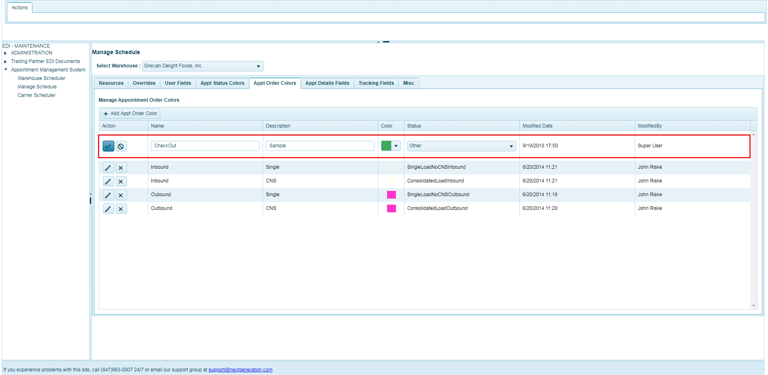

**Delete** **Appointment Orders Colour**

1. The user can delete an appointment orders colours by clicking Delete  button in action column on the row that needs to be deleted from in the list.
2. A confirmation dialog box will be displayed asking the user to confirm deletion of the record.
3. Click “OK” to delete or “Cancel” to cancel deleting the row.

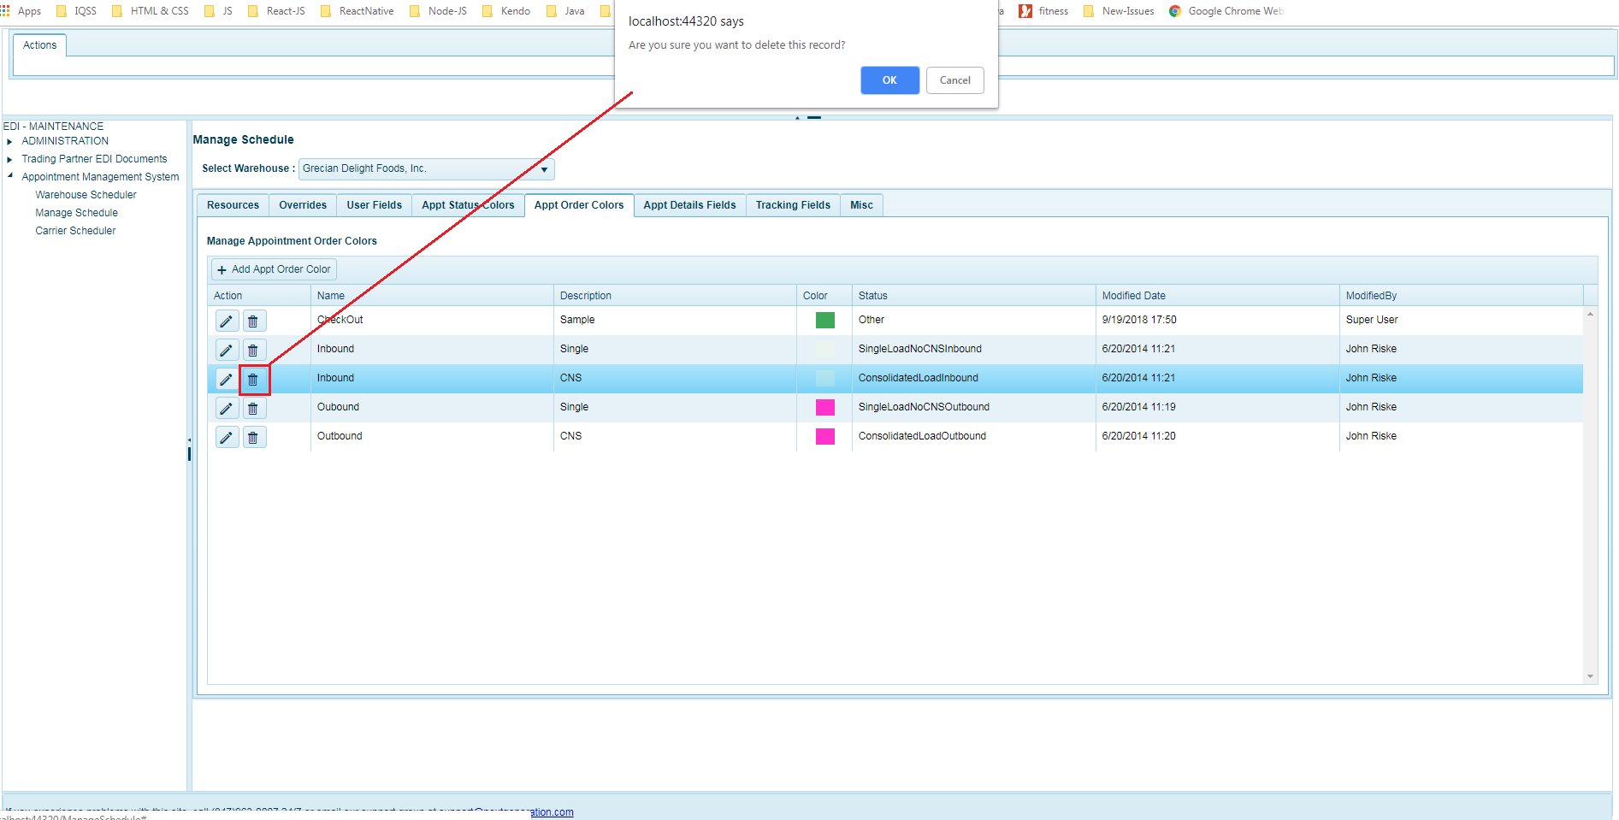

2.6 **Appointment Details Fields**

1. Appointment Details Fields section allows the admin to select the display appointment fields in the scheduler calendar view for a warehouse.
2. Once the fields are selected the admin needs to click on the “Save” button available on top right button of the field’s list grid so that admin can view the selected fields in the appointment in calendar view.

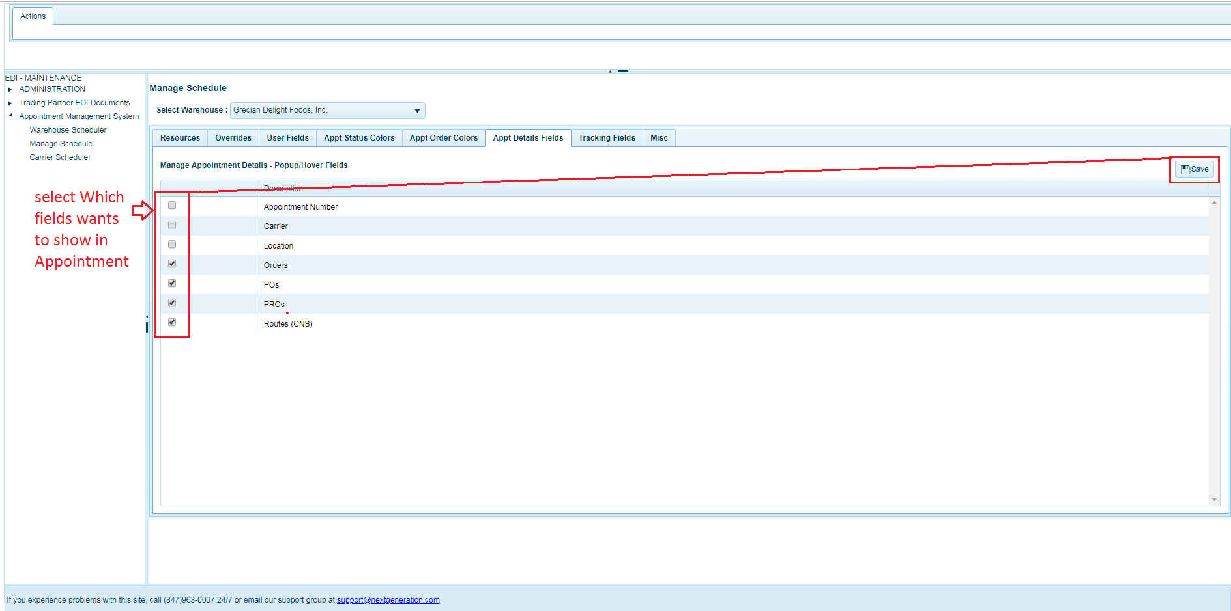

2.7 **Tracking Fields**

The tracking fields section allows the user to add, edit and delete tracking fields colour for the selected warehouse in the dropdown list.

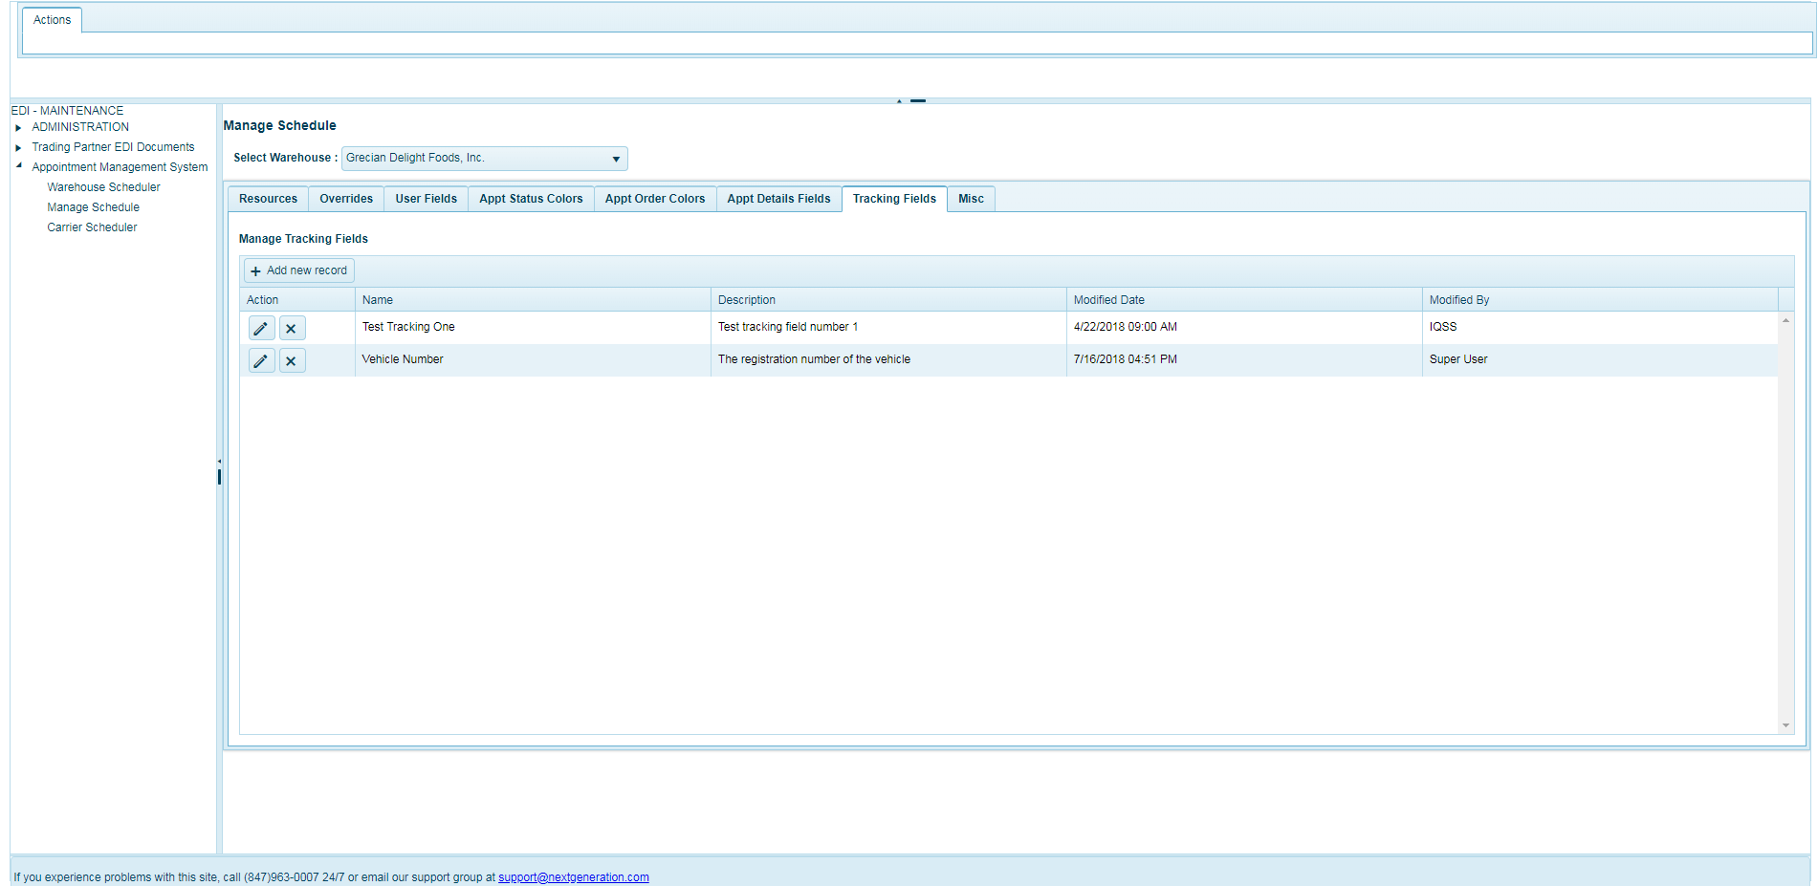

**Add Tracking Fields**

1. Admin can add a new tracking field for the warehouse by clicking on “+Add new record” available in the top toolbar of the tracking fields grid.
2. When the button is clicked the grid that displays a new row with two input fields named as ‘Name’ and ‘Description’ as seen in the screenshot below .
3. Once the details are entered, admin should click save  button to add the new tracking field or they can click clear  button to cancel adding the new tracking field.

**Fields:**

|  |  |  |
| --- | --- | --- |
| **Sl.no** | **Fields Name** | **Details** |
| 1 | Name | Required : Mandatory  Data Type : Alphanumeric |
| 2 | Description | Required : Optional |

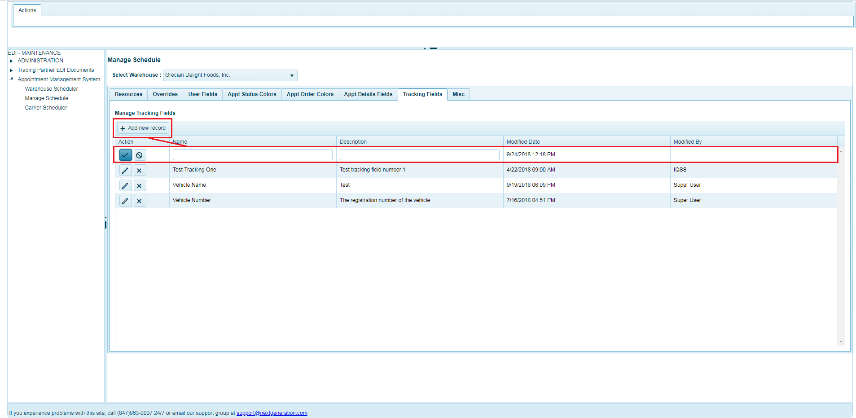

**Edit** **Tracking Fields**

1. The admin can edit details of existing tracking fields by clicking on edit  button available in each row of tracking fields list.
2. They can click on edit button that needs to be edited in left pane the columns will be displayed in edit mode to modify details.
3. Once the details are modified, the admin should click on save  button to save the changes or click cancel  button to cancel the changes.

**Fields:**

|  |  |  |
| --- | --- | --- |
| **Sl.no** | **Fields Name** | **Details** |
| 1 | Name | Required : Mandatory  Data Type : Alphanumeric |
| 2 | Description | Required : Optional |

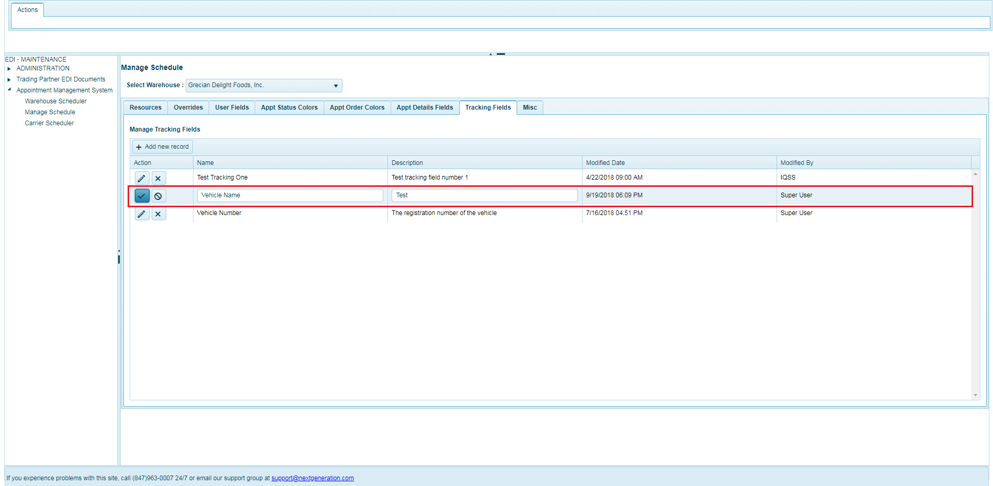

**Delete Tracking Fields**

1. The admin can delete a tracking field by clicking Delete  button in action column lon the row that needs to be deleted from the list.
2. A confirmation dialog box will be displayed asking the user to confirm deletion of the record.
3. Click “OK” to delete or “Cancel” to cancel deleting the row.

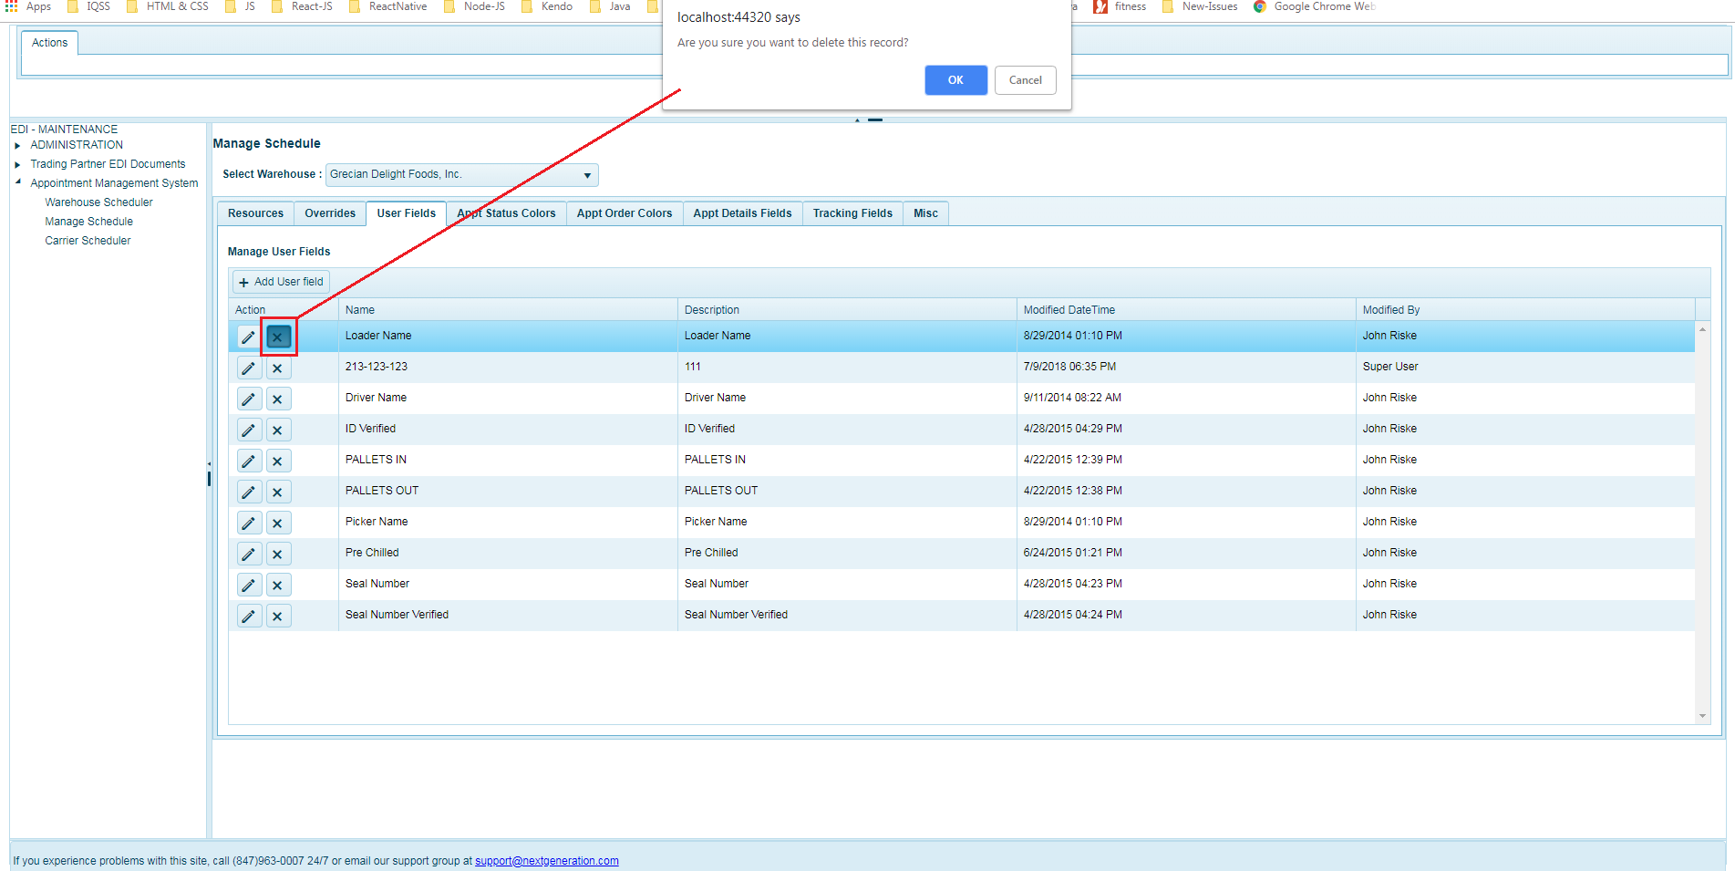

2.8 **Misc.**

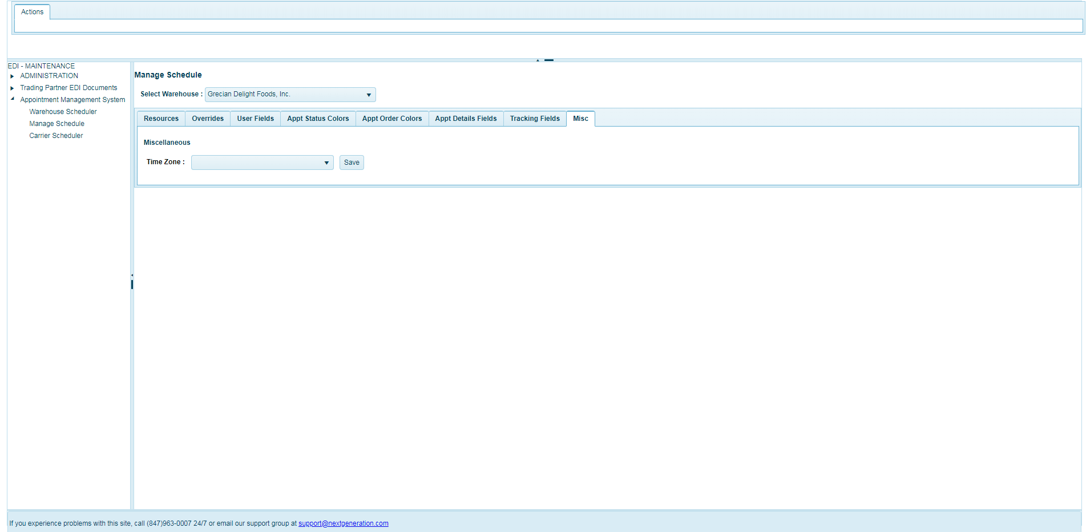

# Carrier Scheduler

The Carrier Scheduler page will be available for the carriers having access to the system and they will be able to schedule an appointment and manage appointments. The appointments and other details available will be confined to the role and access they have been restricted or setup in the system.

In this section the carrier can book an appointment for either pickup or Delivery Order that are pending to schedule an appointment and also manage existing appointments.

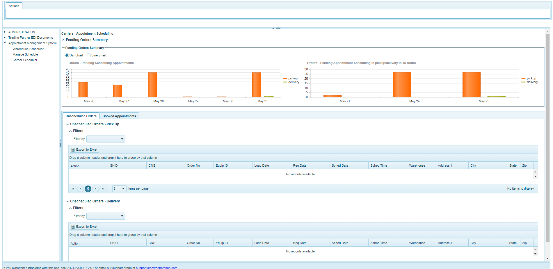

The carrier page mainly has two sections namely “Pending Orders Summary” (Charts) and “Orders grids” that list the orders that are pending an appointment to be scheduled along with appointments that are already scheduled for orders.

* 1. **Pending Orders Summary**

The pending orders summary displays charts providing summary of:

1. The left chart displays the count of orders of next 2 weeks (except tomorrow and next 2 days) yet to be booked an appointment for pickup or delivery
2. The right chart displays the count of orders for tomorrow and next 2 days which have to be scheduled by booking an appointment for pickup or delivery

This section allows the carrier to select the chart type they can view with, they can view the bar chart or the line graph based on the preference as seen in the screenshot below.

**Bar Chart:**

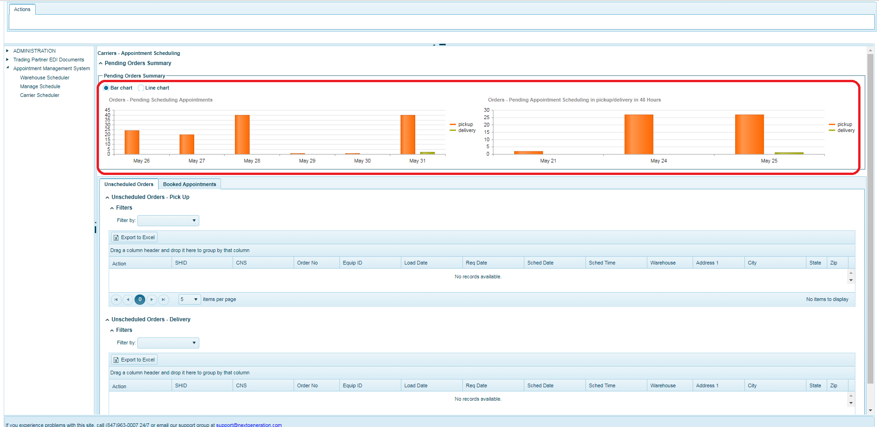

**Line Chart:**

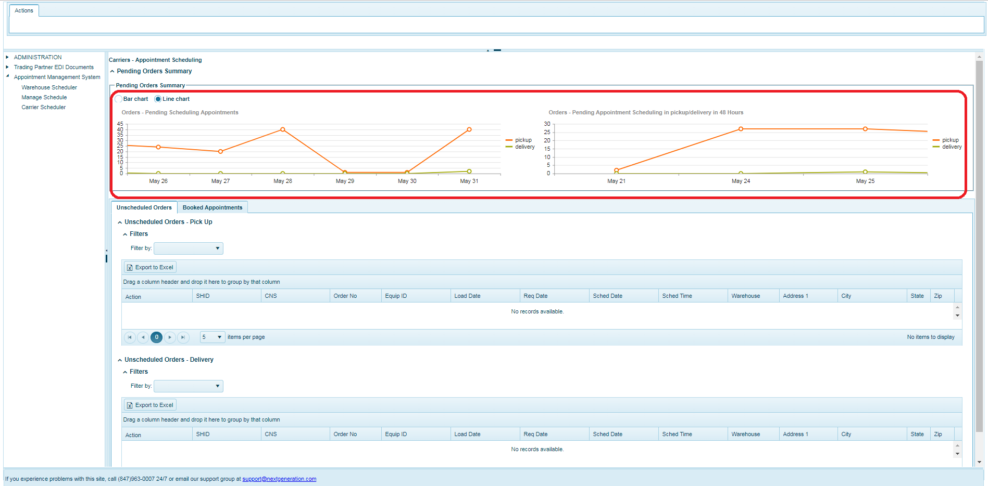

* 1. **Order grids**

The Orders section lists the orders in different tabs namely ‘Unscheduled Orders’ and ‘Booked Appointments’

* + 1. **Unscheduled Orders**

1. The Unscheduled orders displays 2 grids listing the orders for pickup and delivery which are yet to be scheduled by booking an appointment.
2. The 2st orders grid displays the list of pickup orders grid and the 2nd grid lists the order that are to be delivered, as seen in the screenshot below.

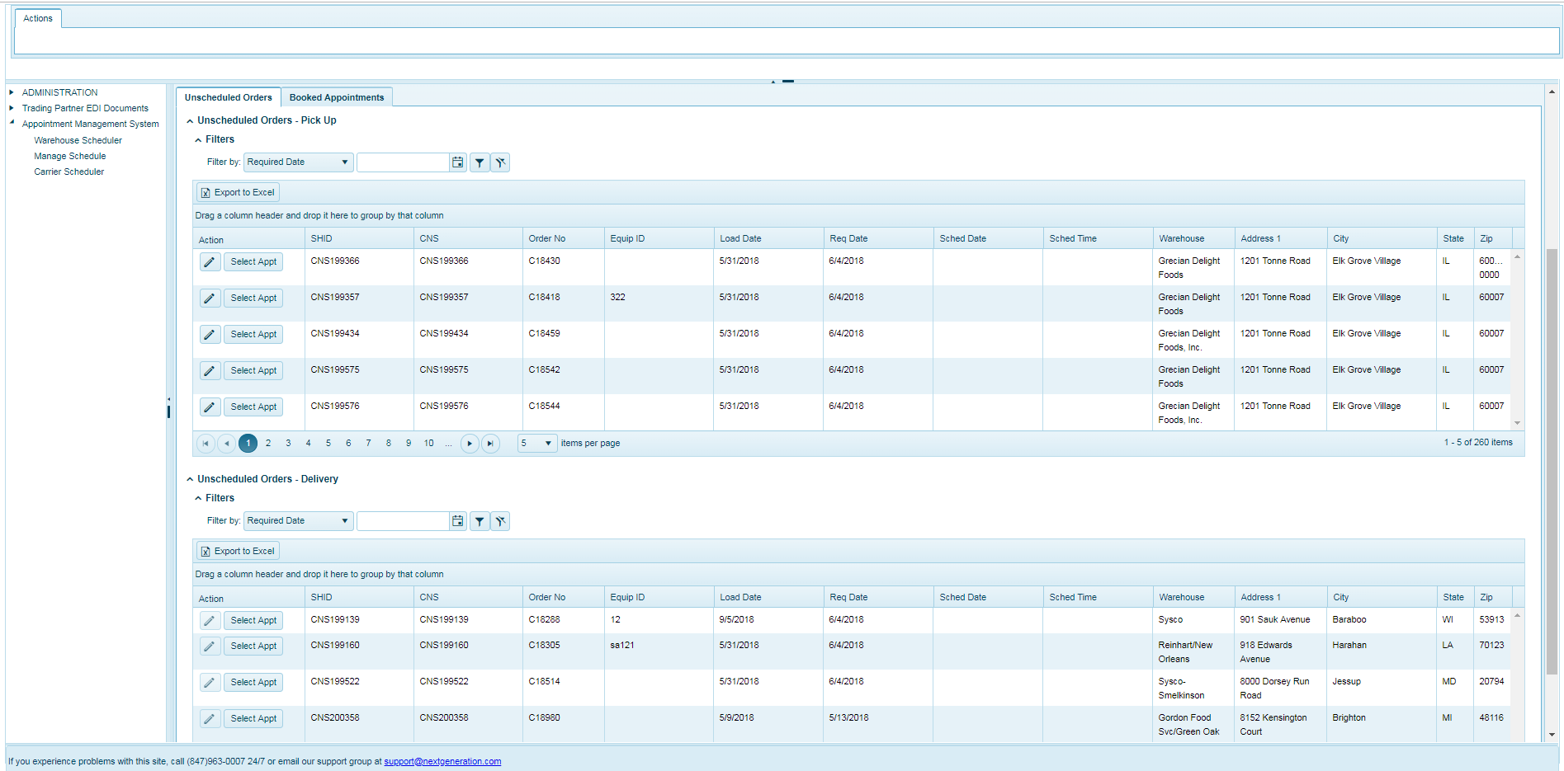

**Edit Order**

1. For unscheduled orders the carrier can only edit the Equipment ID of an order for pickup or delivery, by clicking on edit  button available in each row of orders list in the grid.
2. User can click on edit button that needs to be edited in left pane, the columns will be displayed in edit mode to modify the Equipment ID
3. Once the Equipment ID modified, the user should click on Save  button to save the change or click cancel  button to cancel the change.

**Note:**

1. The Equipment ID is editable for pickup orders only if the order ‘Inbound should be false’ else carrier cannot edit the order.
2. The Equipment ID is allowed to edit for the orders ‘IsTransfer should be false’ and ‘Inbound should be true’ otherwise the carrier cannot edit the order.

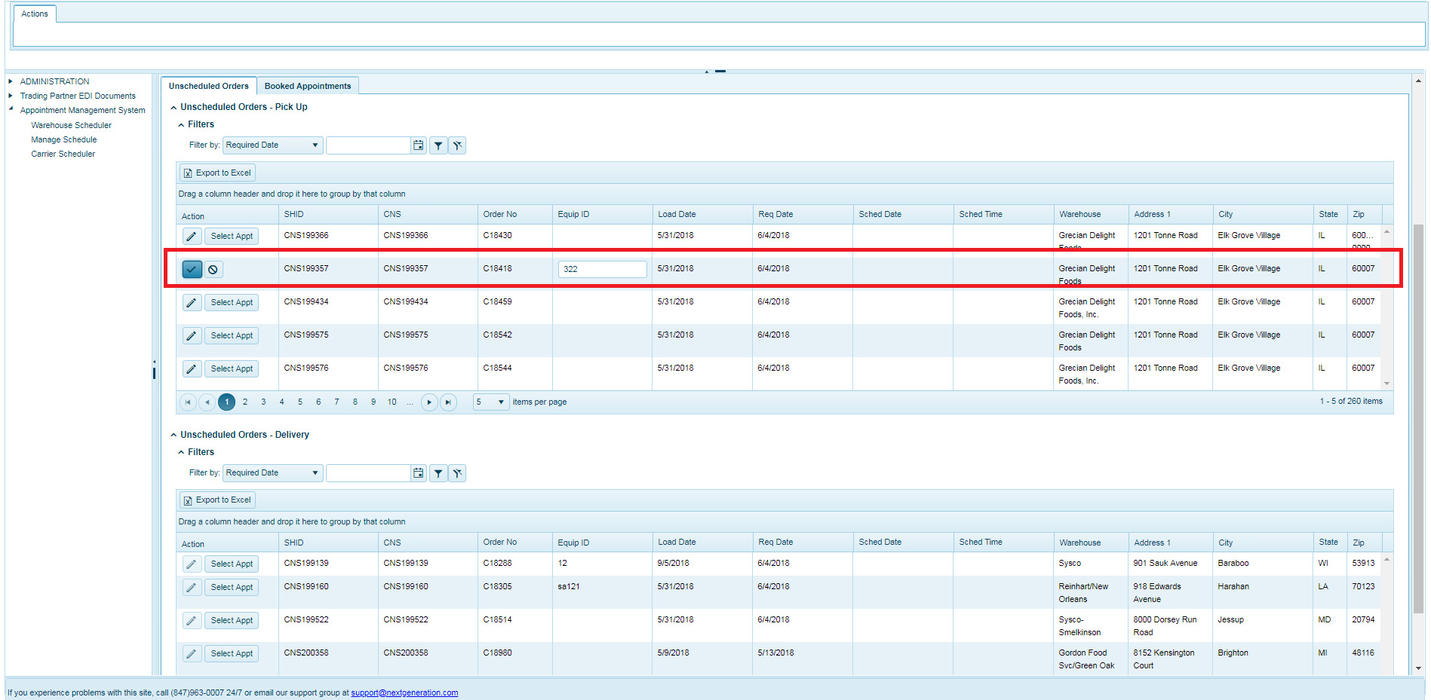

**Book Appointment**

1. The carrier can book an appointment for orders by clicking “Select Appt” available in the each row of the orders list.
2. Once clicking on “select Appt” the popup window opens with the selected order details and Available Appointments list, if the appointments are available for that order as seen in the screenshot below.
3. The carrier can book the appointment by clicking “Book Appt” button in Action column of the appropriate warehouse & the time period from the list of appointments listed.

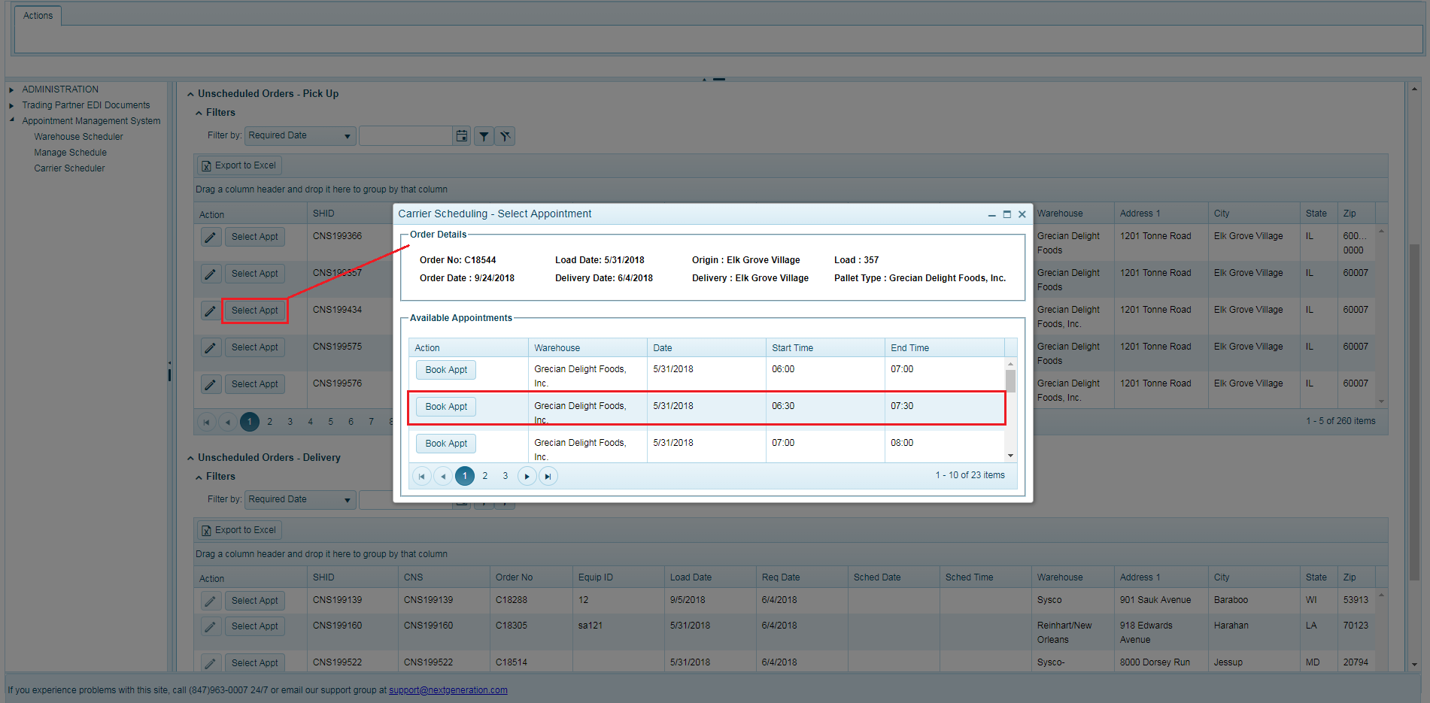

**Request for Book Appointment**

1. This feature is available when there are no appointments available or listed, the carrier can ‘Request an Appointment’ by sending an email request if the pickup or delivery order does not have any available appointments after clicking the “Select Appt” button available in each row of the orders list.
2. The Email Request popup window displays with request subject, body and comments box of the email as in the screenshot below.
3. Once the carrier enters the comments for that email request, they can send email by clicking “Submit Request” or can cancel simply closing the popup window.

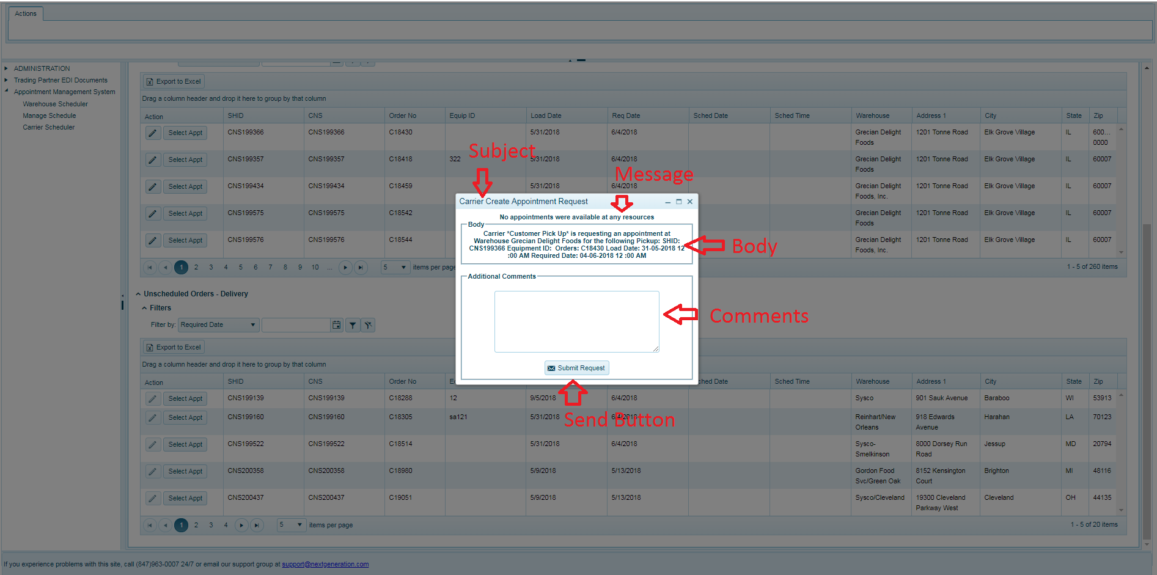

**Filter Orders list**

This feature enables the carrier to search for the Orders based on different criteria and the user can filter the list of orders using the Filter feature available in the page by selecting an option from filter dropdown.

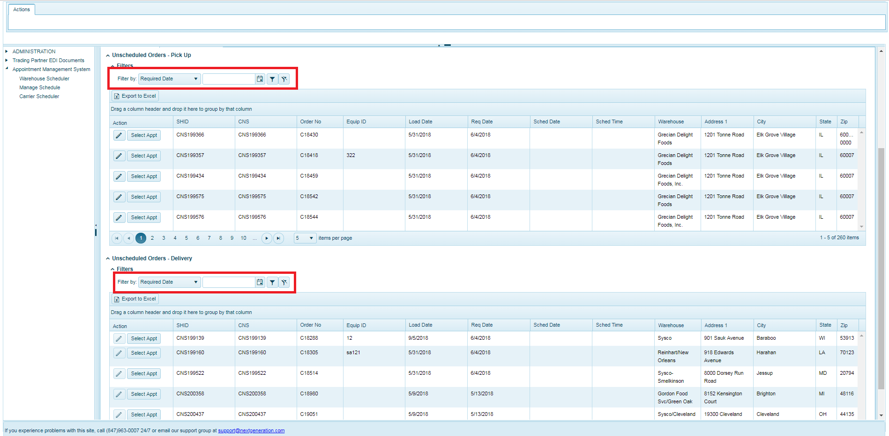

* + 1. **Booked Appointments**

1. The Booked Appointments tab has 2 grids that list the pickup and delivery orders for ones the appointment is already scheduled in the system.
2. The 1st orders grid displays the list of pickup orders and the 2nd grid lists the delivery orders.

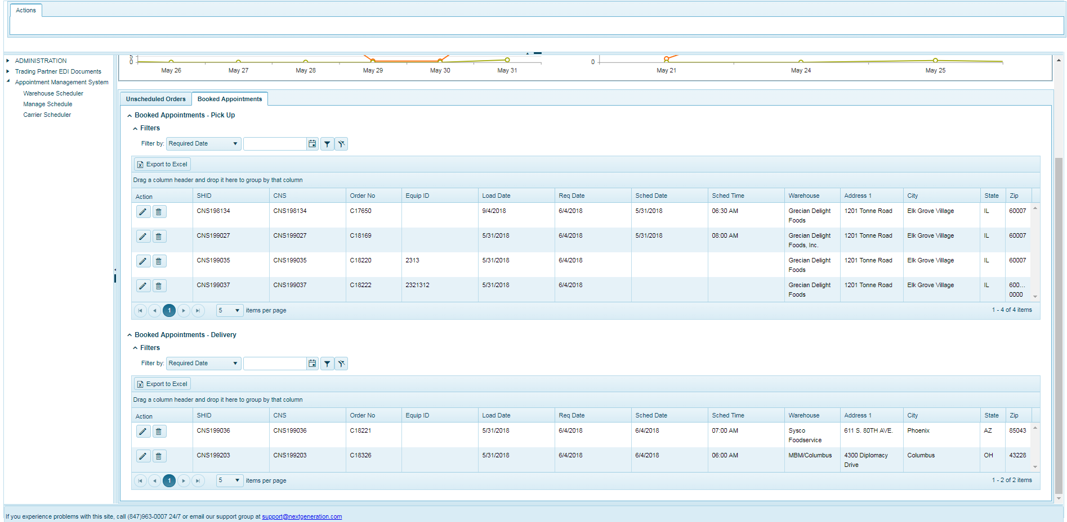

**Edit/Update Appointment for Orders**

1. The carrier can edit appointment for an booked pickup or delivery Orders by clicking on edit  button available in each row of orders list in the grid.
2. The carrier can click on edit button for the popup window to open with the Order details and the available appointments for the orders.
3. Once the available appointments are displayed, list carrier can select updated appointment time slot by clicking the “Book Appt” button in particular row of the Appointments list as seen in screenshot below.

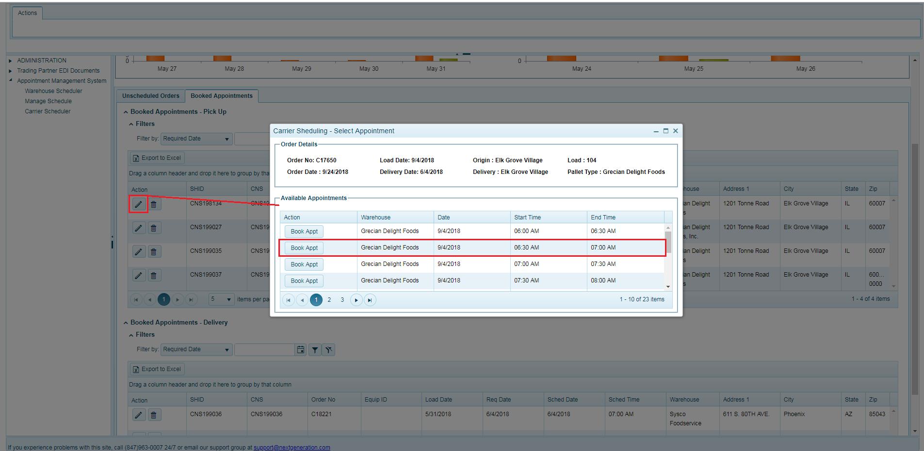

**Delete Appointment**

The carrier can delete by clicking on Delete  button of an order in the list of the orders only if they permission to delete particular booked order appointment.

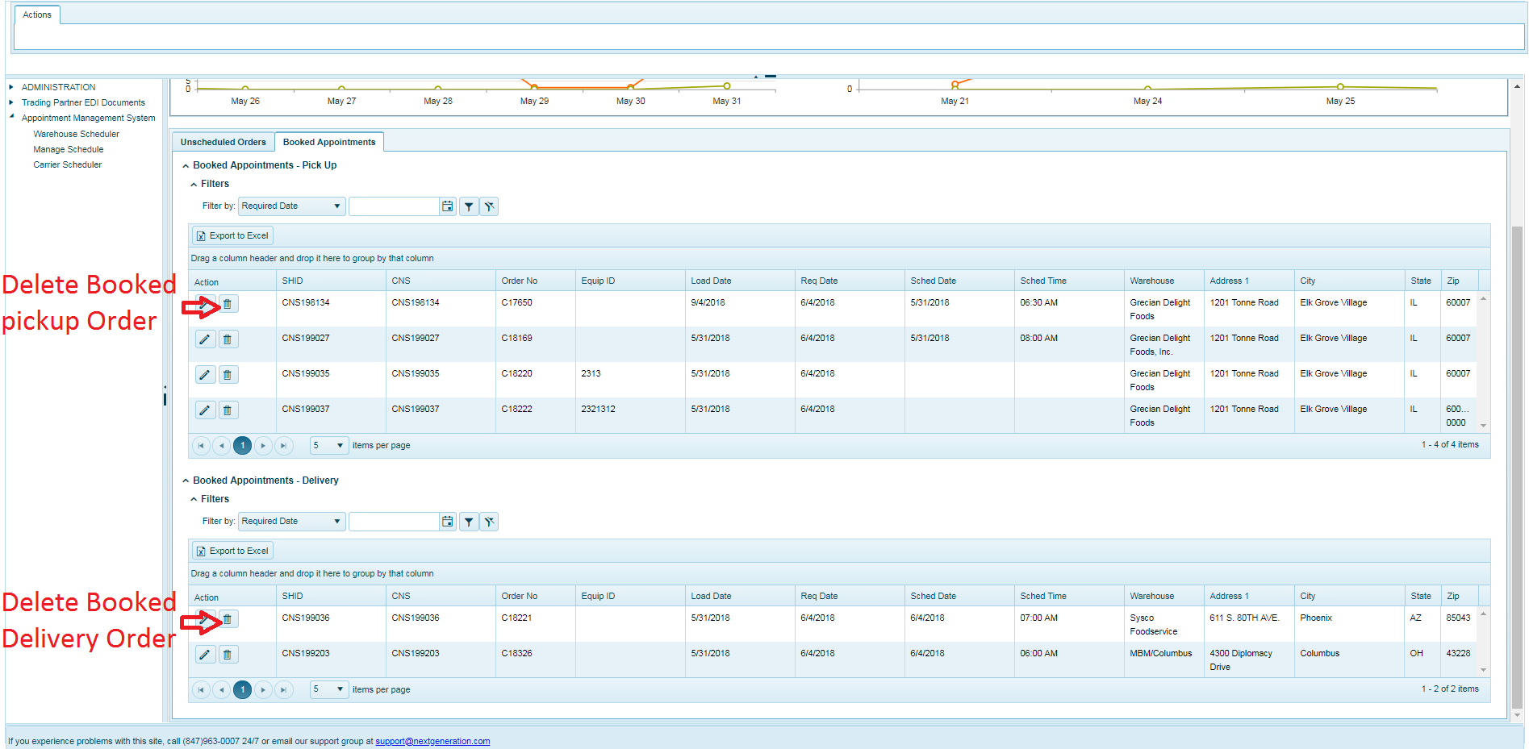

**Request for Book Appointment**

1. The carrier can Request an appointment and also the permission to edit & delete the Booked Appointments of an orders by clicking the Edit  or Delete  button available in the each row of the orders list.
2. Once the carrier clicks Edit or Delete button and if the relevant permission to edit or delete is not available, Email Request popup will display with request Subject, body and comments box of the email as in the screenshot below.
3. Once the comments are entered as part of the email request, carrier can send the email by clicking the “Submit Request” or can cancel by closing the popup window.

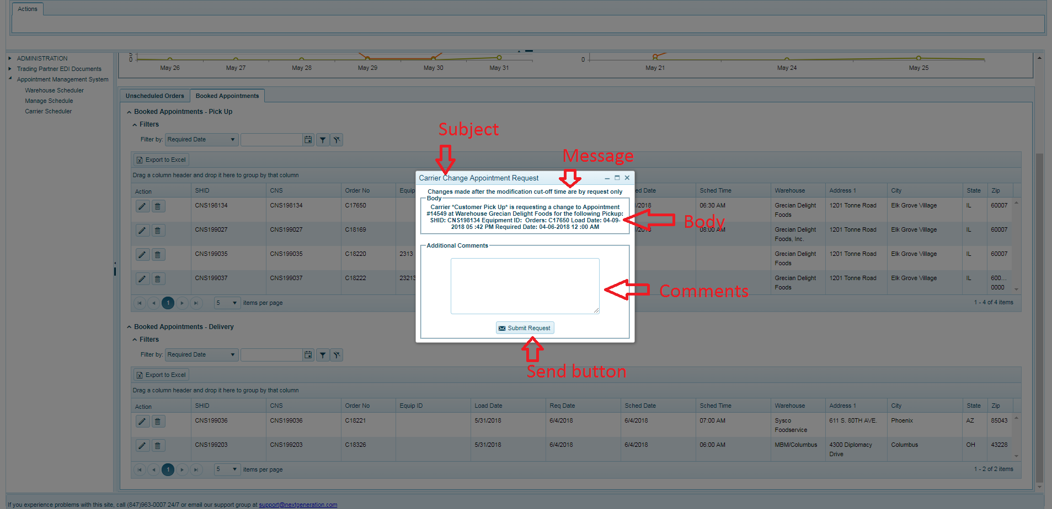

**Filter Orders list**

1. This feature enables the carrier to search the Orders based on different search criteria.
2. The carrier can filter the list of orders using the Filter feature available in the page by selecting an option from filter dropdown.

